CULTURAL IDENTITY  Often cultures can be identified by cultural symbols. Cultural symbols include people, places, objects, hobbies, particular clothes and foods.  British cultural symbols are debatable but might include:  The Royal family  fish and chips  cricket  cup of tea  rainy days!   | wHY DO SCHOOLS PROMOTE BRITISH VALUES?  The British values were created by the Government as part of a response to prevent the radicalization of young or vulnerable people (Prevent 2011).  Through the promotion of British values within school, pupils will be able to ‘develop and demonstrate skills and attitudes that will allow them to participate fully in and contribute positively to life in modern Britain’ (Ofsted 2015).  Promoting British Values in schools is an extremely positive thing. The social development of pupils can be judged by the acceptance and engagement with the five fundamental British values explained overleaf. | British Values    A WILLIAM LILLEY GUIDE
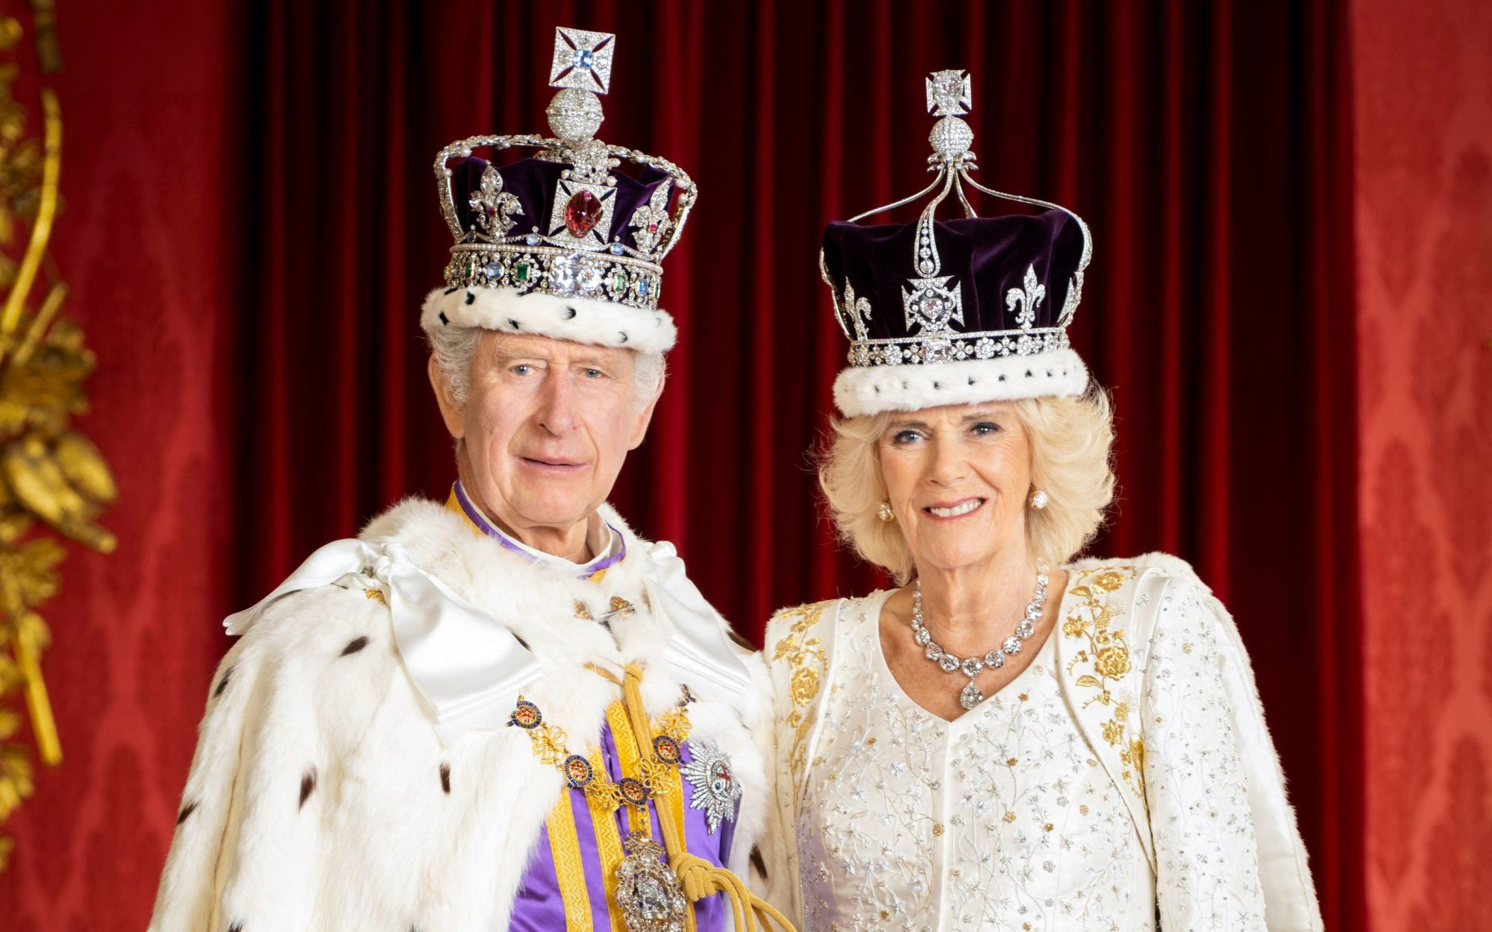 | Should you wish to find out any more information about British Values at William Lilley please call in to see us or alternatively call  01159 179277 | 
what are British Values?  All maintained schools must meet the requirements set out to promote the spiritual, moral, social and cultural (SMSC) development of their pupils. Through ensuring pupils’ SMSC development, schools should actively promoting fundamental British values.  Schools should promote the fundamental British values of democracy  the rule of law  individual liberty  mutual respect  tolerance of those with different faiths and beliefs   | Democracy  It is important to respect other peoples’ views and allow everyone to share their opinions.  We ensure that pupils are given a ‘voice’ to communicate and opportunities to make choices. We have an active School Council and pupils vote for council members and on whole school matters.  Rule of law  The law is important. It ensures that everyone’s rights are respected and everyone is kept safe.  We involve pupils in taking responsibility for their own behaviour; helping pupils to make decisions and choices that are acceptable to the school community and society at large.  Individual liberty  We are free to make our own choices and express our individuality. Pupils are encouraged to become good and valued citizens.  We support each pupil to become as independent as possible. We endeavour to demonstrate that everyone has rights; this includes the right to say 'Yes' or 'No' to ideas or activities. We support others by participating in charitable events. | Mutual respect  We respect the values, ideas and beliefs and others whilst not imposing our own on others.  We promote each pupil’s inclusion in activities that are appropriate to them individually, to meet their needs. Within school, pupils work with a range of people and interactions with others are always positively promoted.  Tolerance of those with different faiths  It is important to value the tolerance of others with different faiths and those with no faith.  We place great emphasis on providing encounters and participation in events and celebrations to broaden all pupils’ experiences and awareness of others.  Our Assemblies help all pupils to find out about themselves and others.  Although some of our pupils may find it difficult to articulate their feelings and concerns; staff are attuned to changes in demeanour and well-being.
CULTURAL IDENTITY  Often cultures can be identified by cultural symbols. Cultural symbols include people, places, objects, hobbies, particular clothes and foods.  British cultural symbols are debatable but might include:  The Royal family  fish and chips  cricket  cup of tea  rainy days! | wHY DO SCHOOLS PROMOTE BRITISH VALUES?  The British values were created by the Government as part of a response to prevent the radicalization of young or vulnerable people (Prevent 2011).  Through the promotion of British values within school, pupils will be able to ‘develop and demonstrate skills and attitudes that will allow them to participate fully in and contribute positively to life in modern Britain’ (Ofsted 2015).  Promoting British Values in schools is an extremely positive thing. The social development of pupils can be judged by the acceptance and engagement with the five fundamental British values explained overleaf. | British Values  A WILLIAM LILLEY GUIDE
Should you wish to find out any more information about British Values at William Lilley please call in to see us or alternatively call
01159 179277
what are British Values?  All maintained schools must meet the requirements set out to promote the spiritual, moral, social and cultural (SMSC) development of their pupils. Through ensuring pupils’ SMSC development, schools should actively promoting fundamental British values.  Schools should promote the fundamental British values of democracy  the rule of law  individual liberty  mutual respect  tolerance of those with different faiths and beliefs | Democracy  It is important to respect other peoples’ views and allow everyone to share their opinions.  We ensure that pupils are given a ‘voice’ to communicate and opportunities to make choices. We have an active School Council and pupils vote for council members and on whole school matters.  Rule of law  The law is important. It ensures that everyone’s rights are respected and everyone is kept safe.  We involve pupils in taking responsibility for their own behaviour; helping pupils to make decisions and choices that are acceptable to the school community and society at large.  Individual liberty  We are free to make our own choices and express our individuality. Pupils are encouraged to become good and valued citizens.  We support each pupil to become as independent as possible. We endeavour to demonstrate that everyone has rights; this includes the right to say 'Yes' or 'No' to ideas or activities. We support others by participating in charitable events. | Mutual respect  We respect the values, ideas and beliefs and others whilst not imposing our own on others.  We promote each pupil’s inclusion in activities that are appropriate to them individually, to meet their needs. Within school, pupils work with a range of people and interactions with others are always positively promoted.  Tolerance of those with different faiths  It is important to value the tolerance of others with different faiths and those with no faith.  We place great emphasis on providing encounters and participation in events and celebrations to broaden all pupils’ experiences and awareness of others.  Our Assemblies help all pupils to find out about themselves and others.  Although some of our pupils may find it difficult to articulate their feelings and concerns; staff are attuned to changes in demeanour and well-being.

