WILLIAM LILLEY INFANT
AND NURSERY SCHOOL

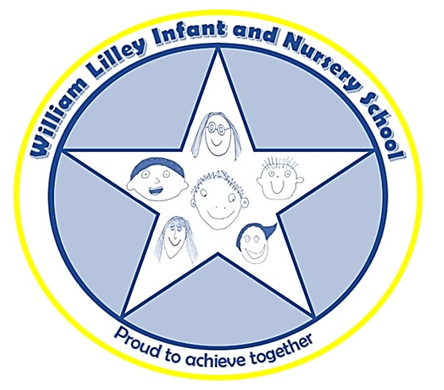

CHILD FRIENDLY
BEHAVIOUR POLICY
At William Lilley Infant and Nursery School everyone works together, to help others feel happy, safe and secure. 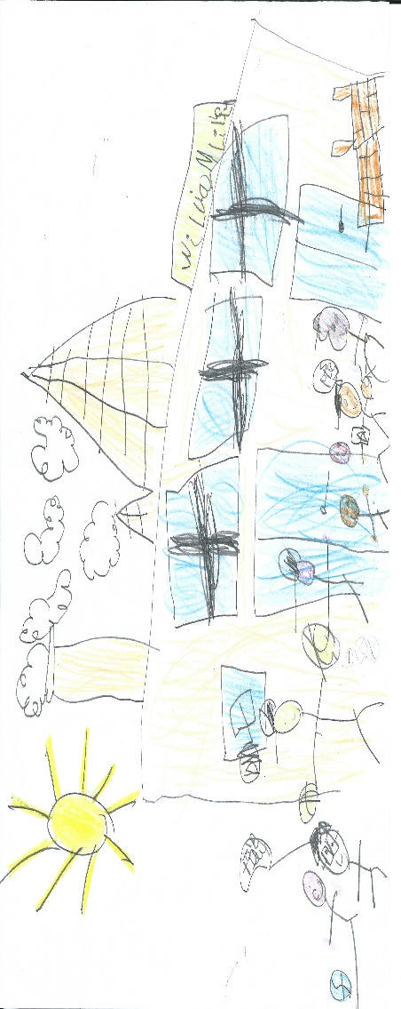

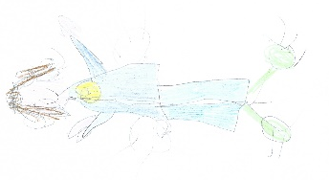
We want children to learn to…
- Be caring
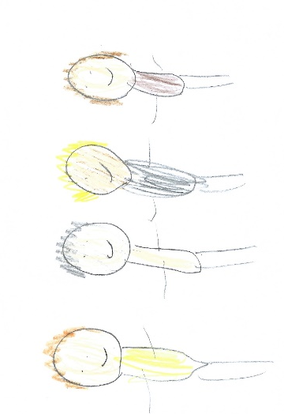
- Feel valued
- Taking pride in ourselves, our friends and our environment
- Make friends
- Be confident
- Be responsible
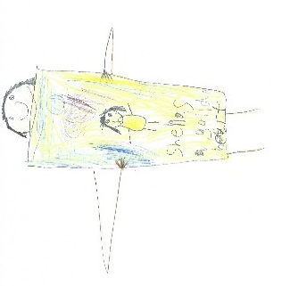
- Co-operate
- Compromise
- Have good manners
- Respect ourselves and others
- treat others how you want to be treated
- Know the difference between right and wrong

When we are learning about these, we are also learning about British Values.
Democracy
Individual Liberty
Rule of Law

Respect for all

Our proud rules

At William Lilley, we are all ‘proud’.
P olite
R espectful
o rganised
u nderstanding
D etermined

We try hard to keep our ‘proud’ rules and get ‘proud’ points when we do this!
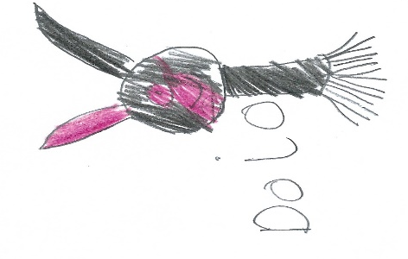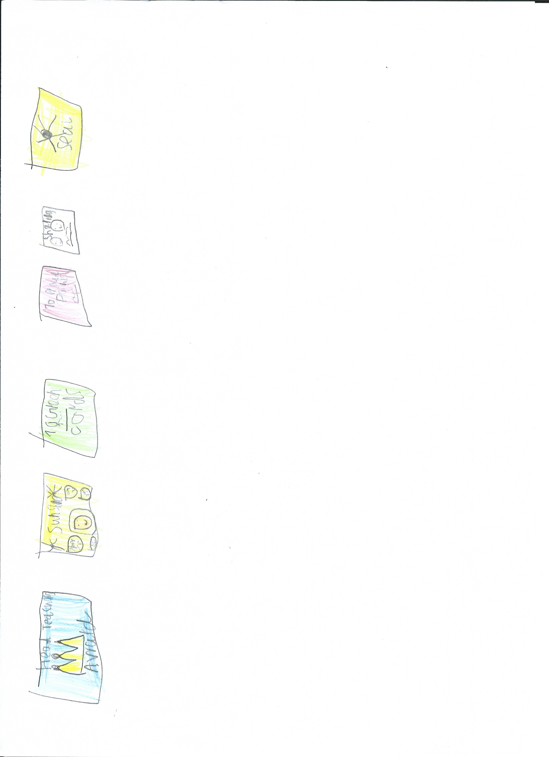

We get lots of other rewards too!

We learn to keep our ‘PROUD’ rules

Through SEAL  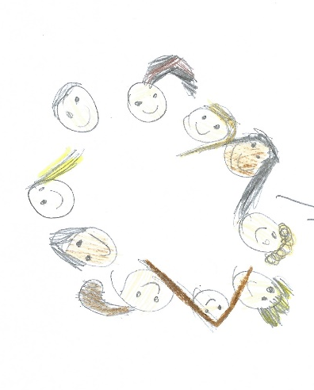 | SEAL Sunshines  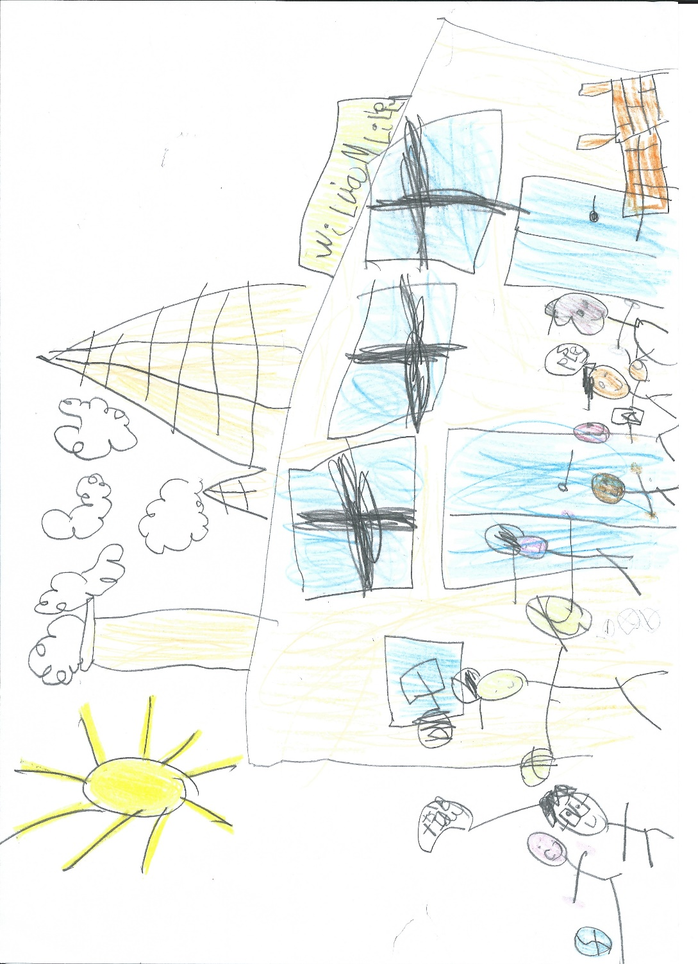
PSED where we learn to work together  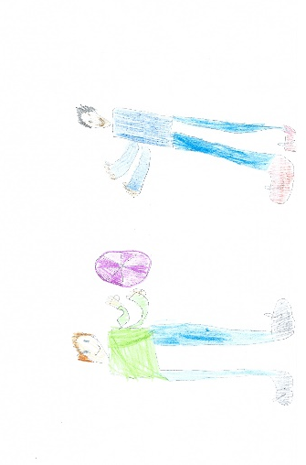 | And other things like Yoga and success in schools  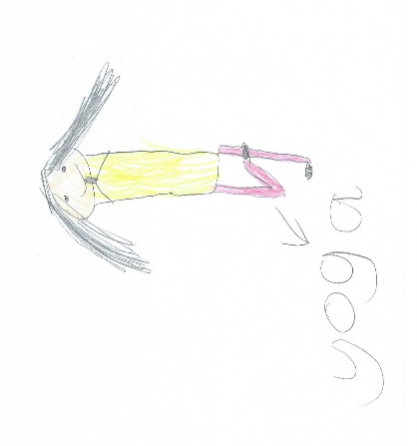

We learn to make the right choices
We use a traffic light system to help us make the right choice.

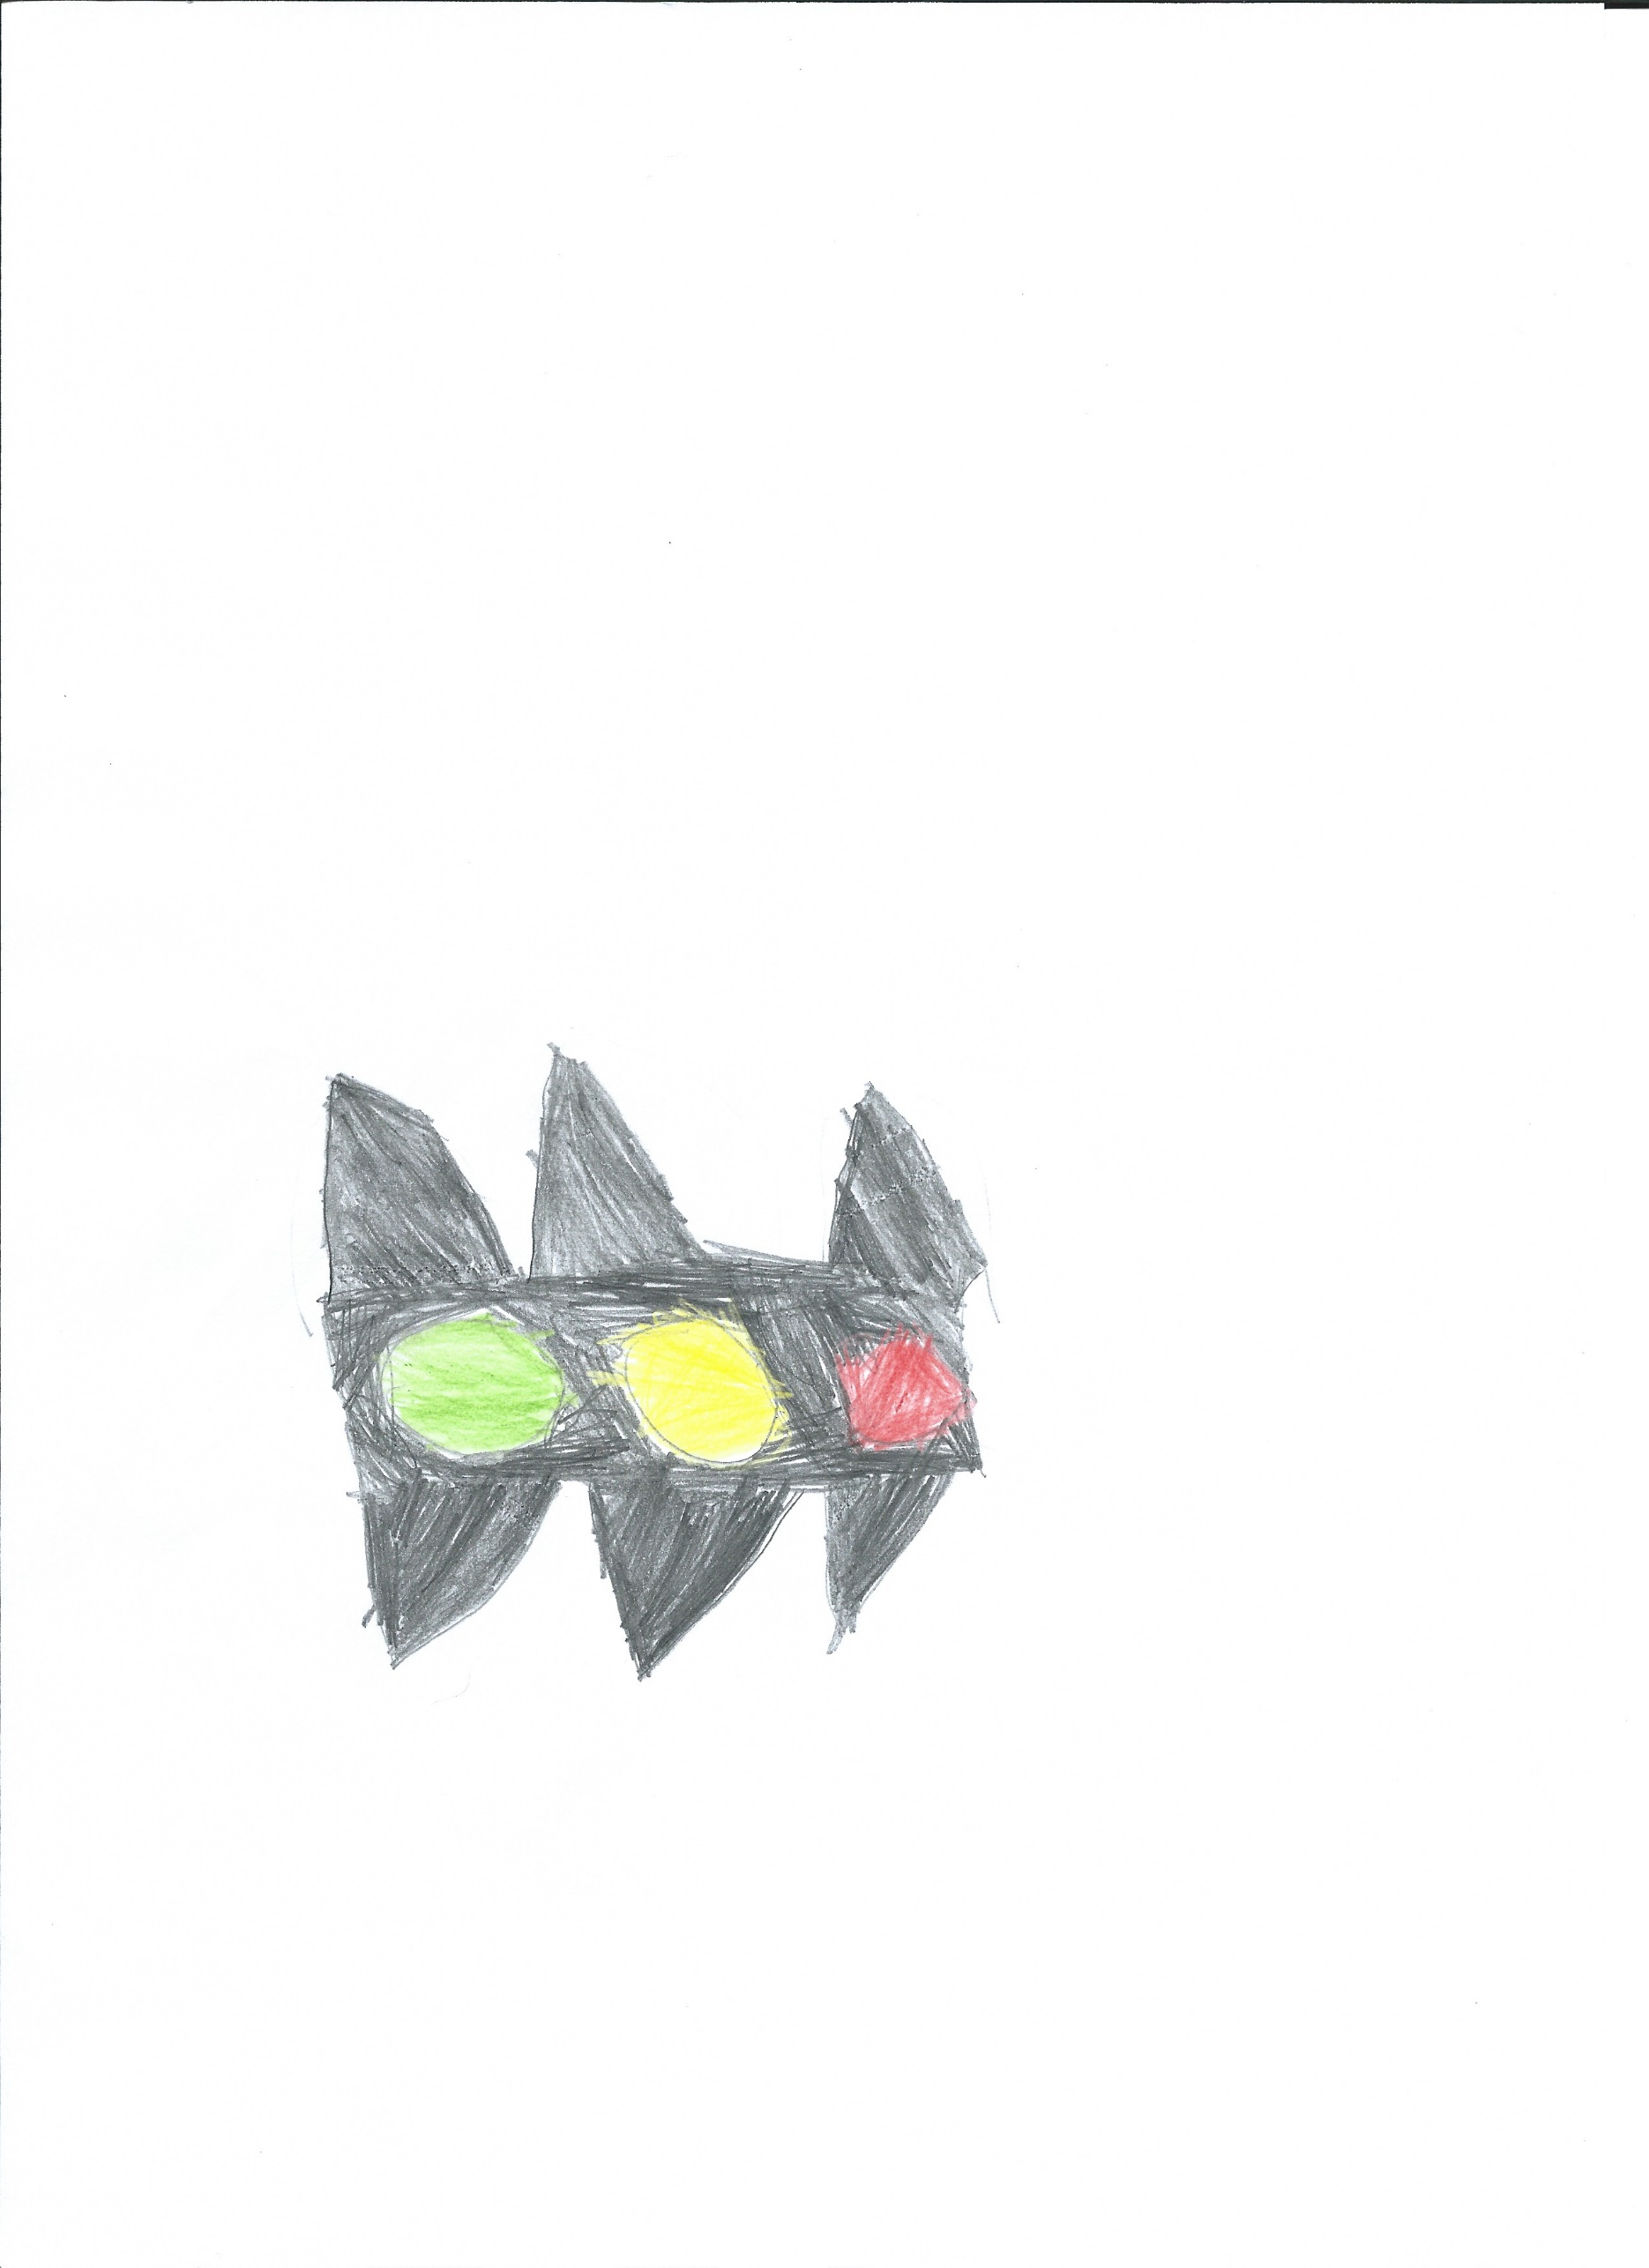
For really good choices
☺
For making the right choice
😐
For making the wrong choice.
☹
For making two wrong choices or a really wrong choice.

If a child makes the wrong choice, then they can try to get back to the green smiley face.

At the end of the week, we have 20 minutes Proud time. If a child ends the day on a yellow face, they miss 2 minutes of their Proud time. If they end the day on a red face, they miss 4 minutes of their Proud time.

Sometimes, a child will need special targets to help them keep our ‘proud’ rules. If this happens, then they will talk about this with their parents and grown-up’s at school.

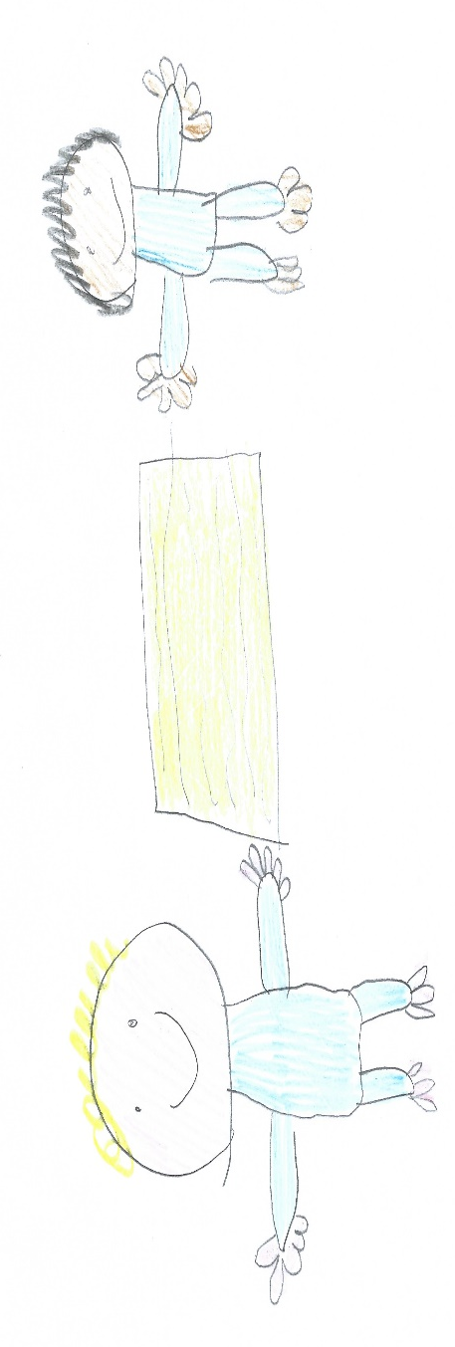
If someone has special targets, this may mean that they have to go on the concentration station in their class for 5 minutes. This helps them to think about making the right choice. If they are still finding it tricky to keep our ‘proud’ rules then they will have 5 minutes in another class. If they are still finding it hard, then they go to see Mrs Beardsley or Miss McMahon who may call their parents.

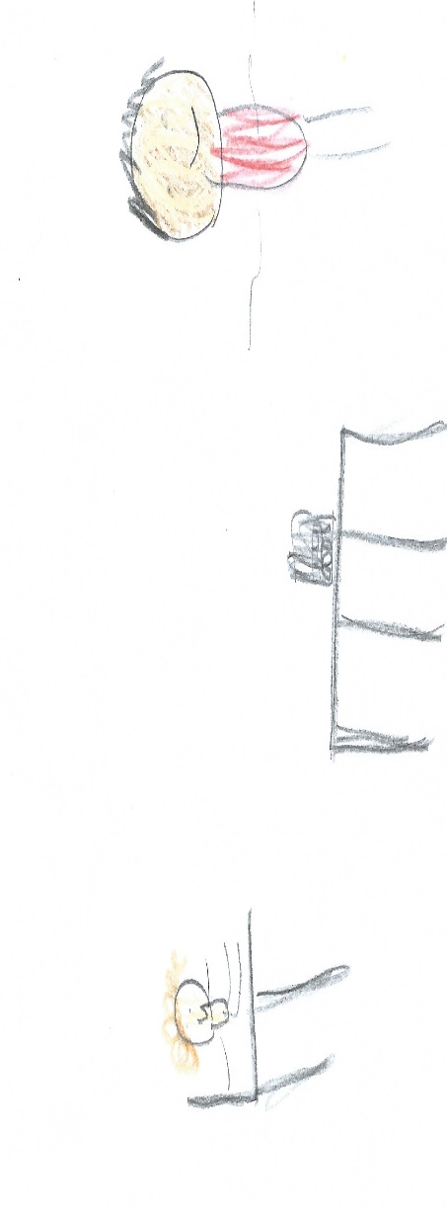

In Nursery

In Nursery, everyone has a busy bee with their name on. They work hard in Nursery to keep ‘Betty Bee’s rules’. When they keep Betty’s rules, they get a sticker. After 5 or 10 stickers, they get a certificate and move onto silver and gold Busy Bee’s!
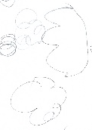
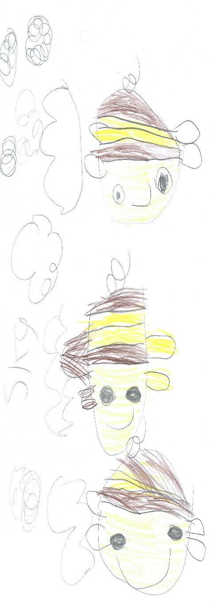

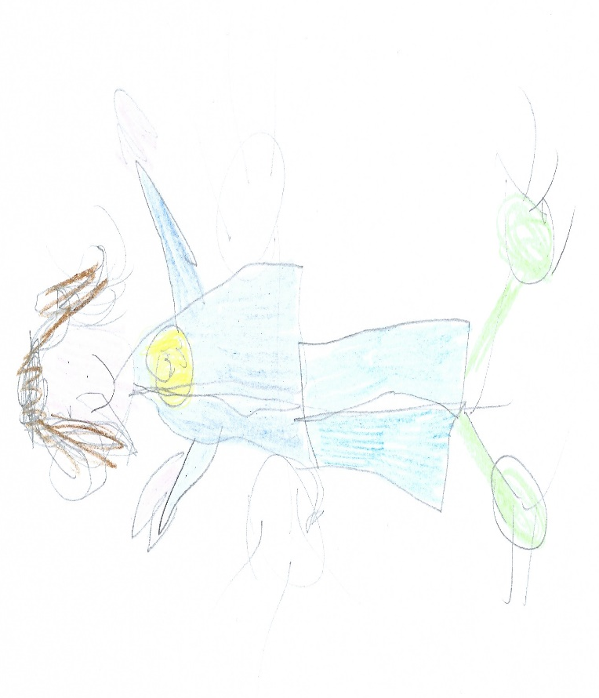
Be PROUD.

