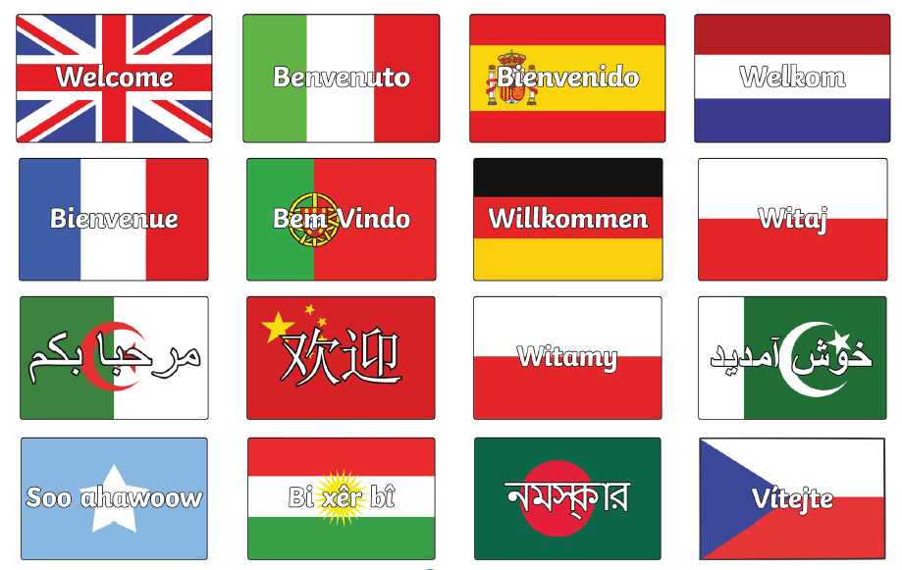

English as an Additional Language (EAL) at William Lilley Infant and Nursery School

Welcome information guide for
New Parents
NURSERY
2023-2024

Hello and Welcome to William Lilley Infant and Nursery School!

We are here to help you and your child settle in at our school.

These are the important members of staff for you:-

  Mrs Jeffery  Early Years coordinator |   Mrs Beardsley  Headteacher |   Miss McMahon  Deputy Headteacher,
  Mrs Jenkins  Office Manager |   Mrs Yard  Office Admin |   Mrs Emery  Office Admin
  Mrs Young  Class Teacher |   Mr Amjed  Class Teacher |   Mrs Westby  Class Teacher


Miss Jones
Class Teacher


Mrs Logue
Teaching Assistant – EAL

William Lilley Infant and Nursery School

Early Years Foundation Stage (EYFS)
Nursery | Aged 3 - 4 | Busy Bees:  - Red group  - Blue group  - Yellow group
Reception | Aged 4 - 5 | Brilliant Butterflies  AND  Lovely Ladybirds
Key Stage 1 (KS1)

Mixed classes with  Year 1Aged 5 -6 AND  Year 2 Aged 6 - 7 |  | Fabulous Flamingos  AND  Persevering Puffins  AND  Curious Kingfishers

The Nursery School Day

Your child may attend for 15 hours OR 30 hours

15 hour patterns include:

- Monday – Friday Mornings including Wednesday lunchtime
- Monday – Friday Afternoons including Thursday lunchtime
- All day Monday, Tuesday and Wednesday morning
- All day Thursday, Friday and Wednesday afternoon

30 hour pattern includes
- Full time from 8.50 – 3.20 Monday to Friday

Please see contract for more details. Please note some of these patterns include an additional charge for lunchtime as the allocation of hours is above 15 hours or 30 hours.

If your child is ill, please ring the office and let the school know

  0115 9179277


Your child will need:

A book bag

Your child will study:

Communication and language
Personal and social development
Physical development
Literacy (English) including phonics
Mathematics
Understanding the world
Expressive Arts and Design
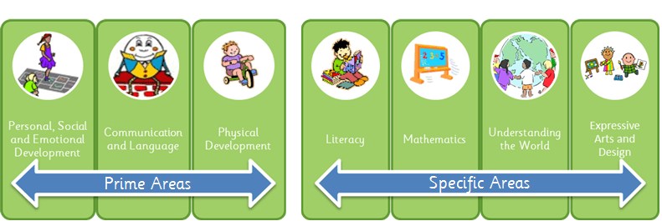

Your child will learn through play, but will also have formal learning sessions in their group.


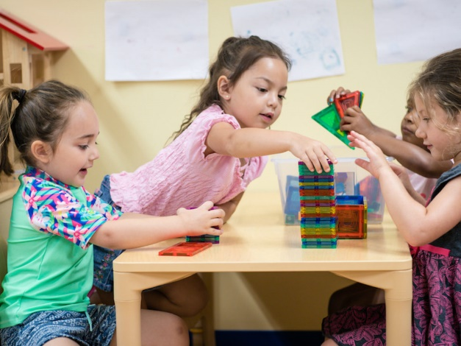

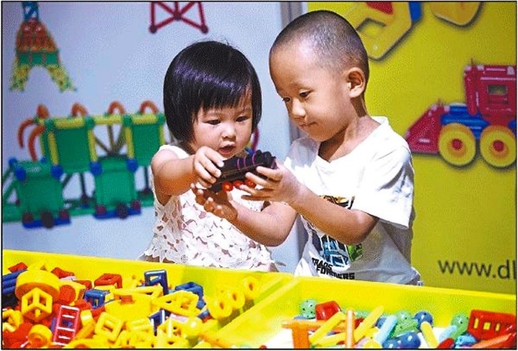

Helping your child

Please help your child by reading their book with them at home.


Your child will get homework each week. Please work on this with your child.


Each term there is a parents evening. Please come along and talk to your child’s teacher about your child’s progress.



Please keep up-to-date by reading the weekly newsletter. This is available on our website www.williamlilley.notts.sch.uk

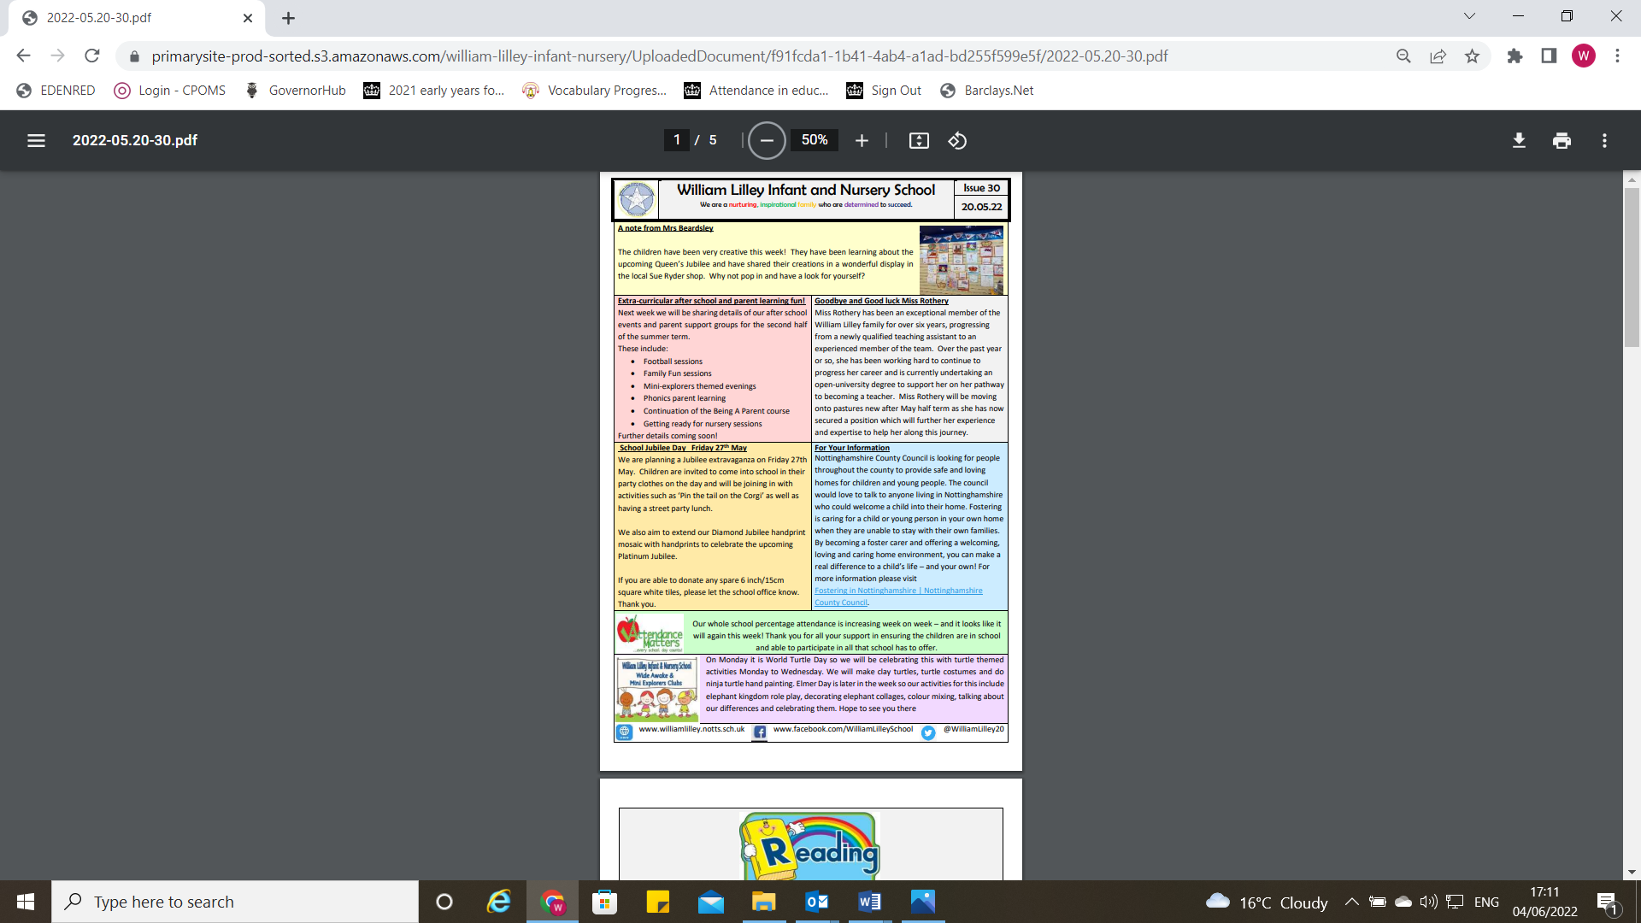

If you need any help, please ask.

School Dinners

You can choose:-

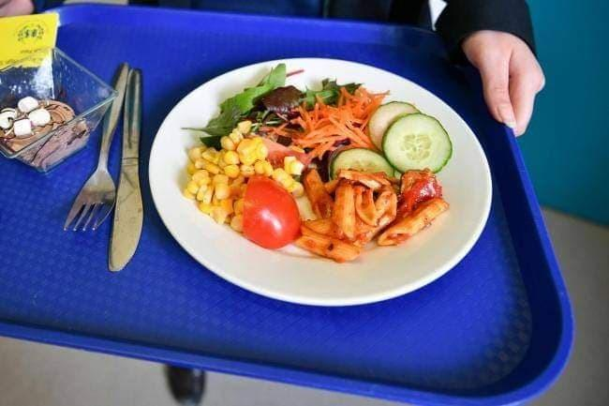  A hot dinner O | 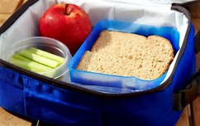  R Sandwiches from home

In Nursery school meals have an additional fee. Please see the office for more details.

Milk


You may want your child to have milk every day at break-time. See staff in the School office for more information.

Allergies and dietary requirements

Please let us know if your child has any food allergies or dietary requirements



School Uniform

Children wear uniform every day to school.

Your child will need:-

A white polo shirt black or grey trousers or skirt
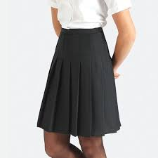
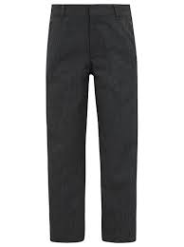
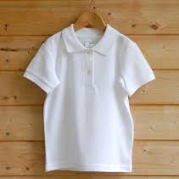

A blue sweatshirt black shoes
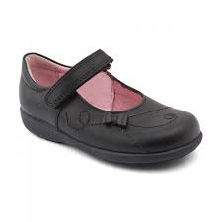
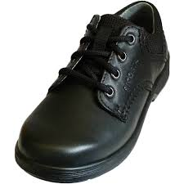

You can purchase your school uniform from Simply First or Morleys

Attendance

Your child should be in school each week.

Please see school timetable for term dates and school holiday dates.


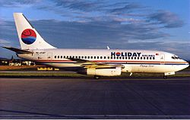
This Photo by Unknown Author is licensed under CC BY-SA

Please do NOT take a holiday during term-time.

Important information

Please be prepared:

 | Bring into school completed yellow forms and contracts.
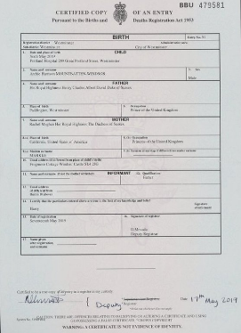 | Show birth certificate or proof of identity.
 | Register for school milk.
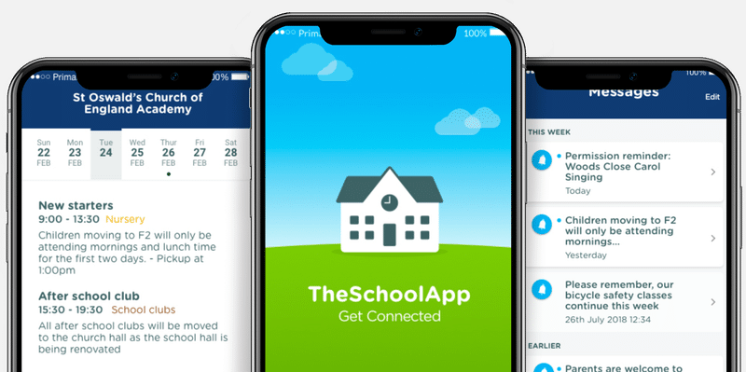 | Register for My School App.
 | Register for Class dojo. Please see your class teacher for more information.

