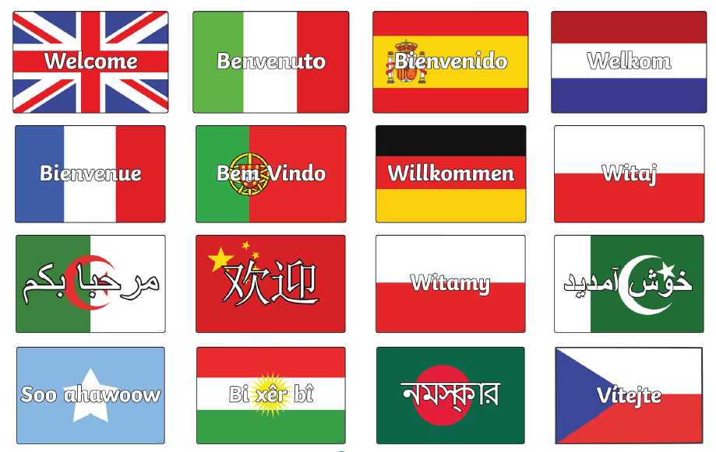

English as an Additional Language (EAL) at William Lilley Infant and Nursery School

Welcome information guide for
New Parents
RECEPTION
2023-2024

Hello and Welcome to William Lilley Infant and Nursery School!

We are here to help you and your child settle in at our school.

These are the important members of staff for you:-

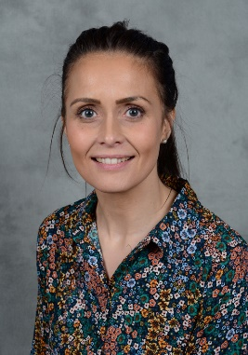  Mrs Jeffery  Early Years coordinator |   Mrs Beardsley  Headteacher | 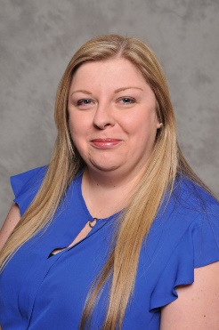  Miss McMahon  Deputy Headteacher,
  Mrs Jenkins  Office Manager |   Mrs Yard  Office Admin | 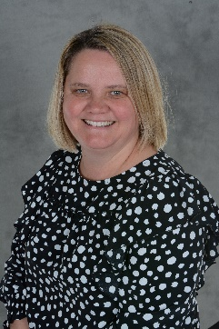  Mrs Emery  Office Admin
  Mrs Young  Class Teacher |   Mr Amjed  Class Teacher |   Mrs Westby  Class Teacher

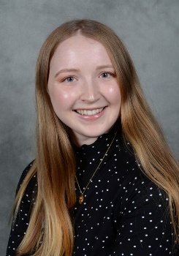
Miss Jones
Class Teacher


Mrs Logue
Teaching Assistant – EAL

William Lilley Infant and Nursery School

Early Years Foundation Stage (EYFS)
Nursery | Aged 3 - 4 | Busy Bees:  - Red group  - Blue group  - Yellow group
Reception | Aged 4 - 5 | Brilliant Butterflies  AND  Lovely Ladybirds
Key Stage 1 (KS1)

Mixed classes with  Year 1Aged 5 -6 AND  Year 2 Aged 6 - 7 |  | Fabulous Flamingos  AND  Persevering Puffins  AND  Curious Kingfishers

The School Day

School starts at 8.45 am

School finishes at 3:15 pm


Your child must attend school Monday – Friday.

If your child is ill, please ring the office and let the school know

  0115 9179277

Your child will need:

A book bag A PE kit (kept at school)

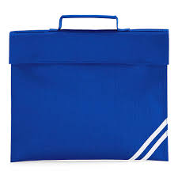
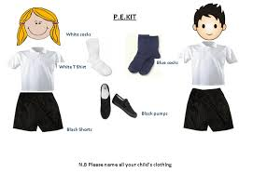

Every day, your child will study:

Communication and language
Personal and social development
Physical development
Literacy (English) including phonics
Mathematics
Understanding the world
Expressive Arts and Design
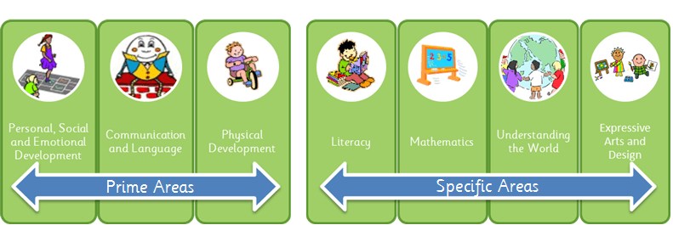

Your child will learn through play, but will also have formal learning sessions.


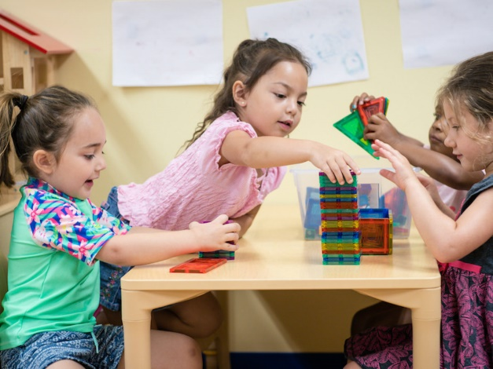

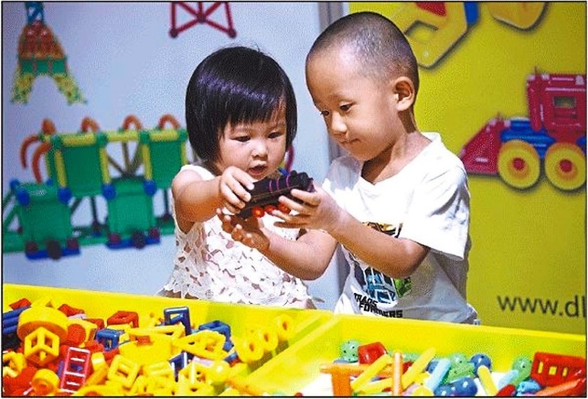

Formal learning sessions

Literacy (English), phonics (learning letter sounds to help to read and write)and Maths


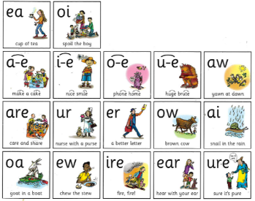
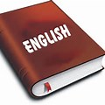

Topic or PE



Helping your child

Please help your child by reading their reading book them at home each day.


Your child will get homework each week. Please work on this with your child.


Each term there is a parents evening. Please come along and talk to your child’s teacher about your child’s progress.



Please keep up-to-date by reading the weekly newsletter. This is available on our website www.williamlilley.notts.sch.uk

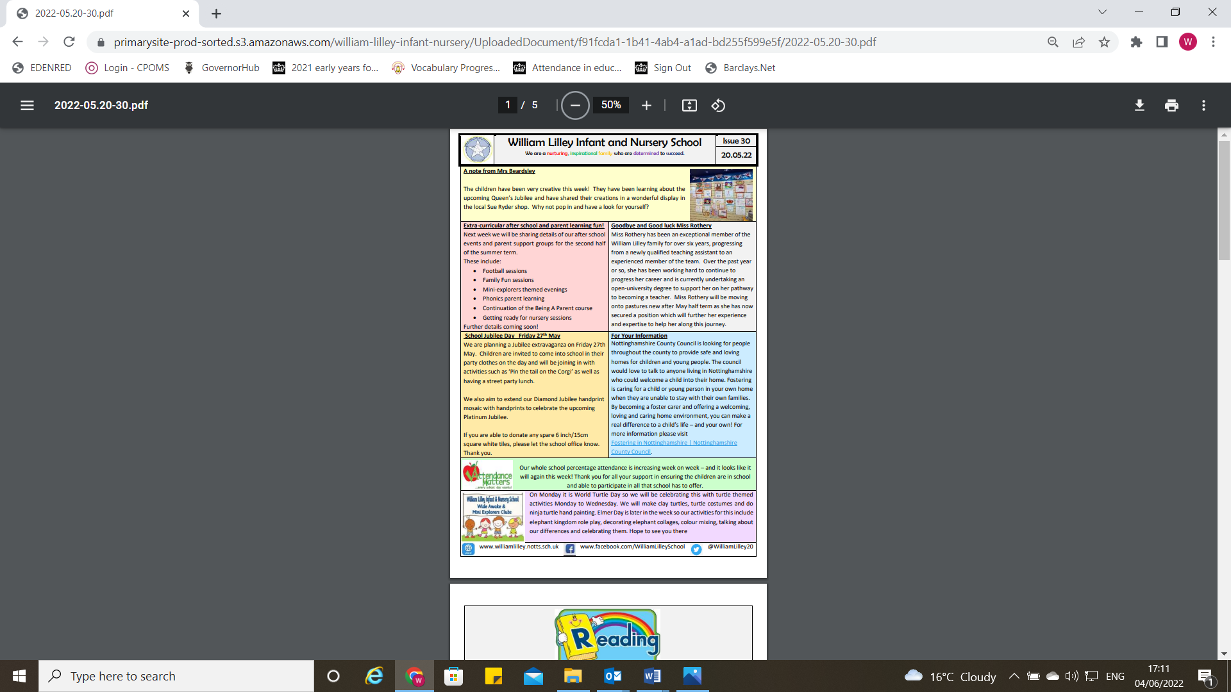

If you need any help, please ask.
School Dinners

You can choose:-

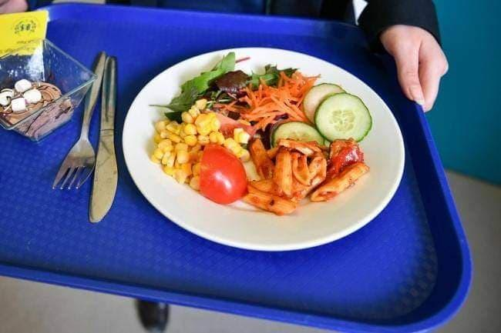  A hot dinner O | 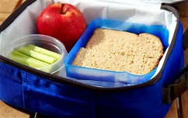  R Sandwiches from home

If your child is in Reception, Year 1 or Year 2, all school meals are free.

Milk

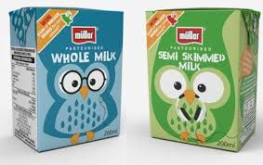
You may want your child to have milk every day at break-time. See staff in the School office for more information.

You may be entitled to Free School Meals. (see attached form)

Allergies and dietary requirements

Please let us know if your child has any food allergies or dietary requirements

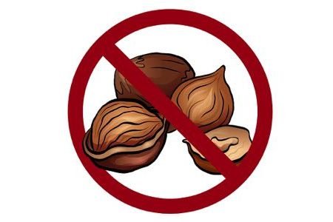
School Uniform

Children wear uniform every day to school.

Your child will need:-

A white polo shirt black or grey trousers or skirt
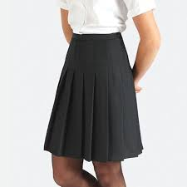
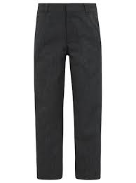
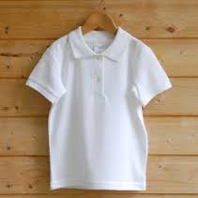

A blue sweatshirt black shoes
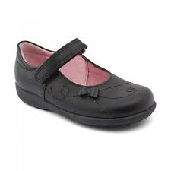
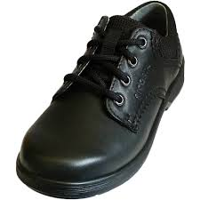

You can purchase your school uniform from Simply First or Morleys

Attendance
Your child should be in school on Monday to Friday each week.

Please see school timetable for term dates and school holiday dates.


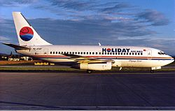
This Photo by Unknown Author is licensed under CC BY-SA

Please do NOT take a holiday during term-time.

You may receive a fine.


Important information

Please be prepared:

 | Bring into school completed yellow forms.
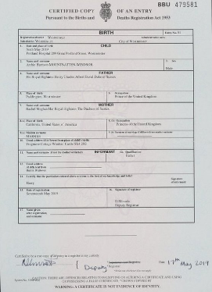 | Show birth certificate or proof of identity.
 | Register for school milk.
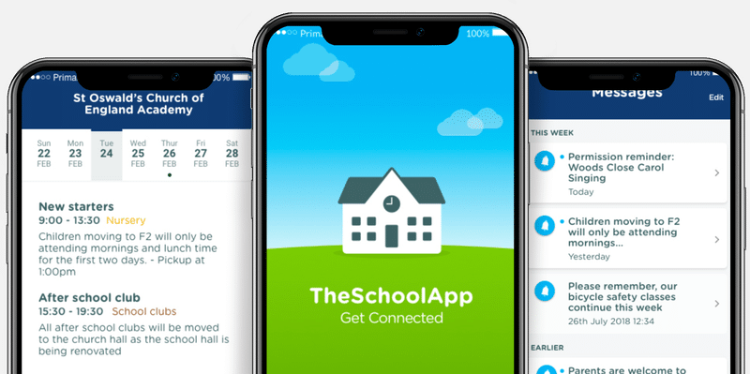 | Register for My School App.
 | Register for Class dojo. Please see your class teacher for more information.

