WILLIAM LILLEY INFANT & NURSERY SCHOOL



WELCOME TO
WILLIAM LILLEY

Useful Information 2024-2025


Keeping In Touch

We use various communication means to ensure that you are kept
informed of latest news and diary dates.

Please subscribe to or visit the below.
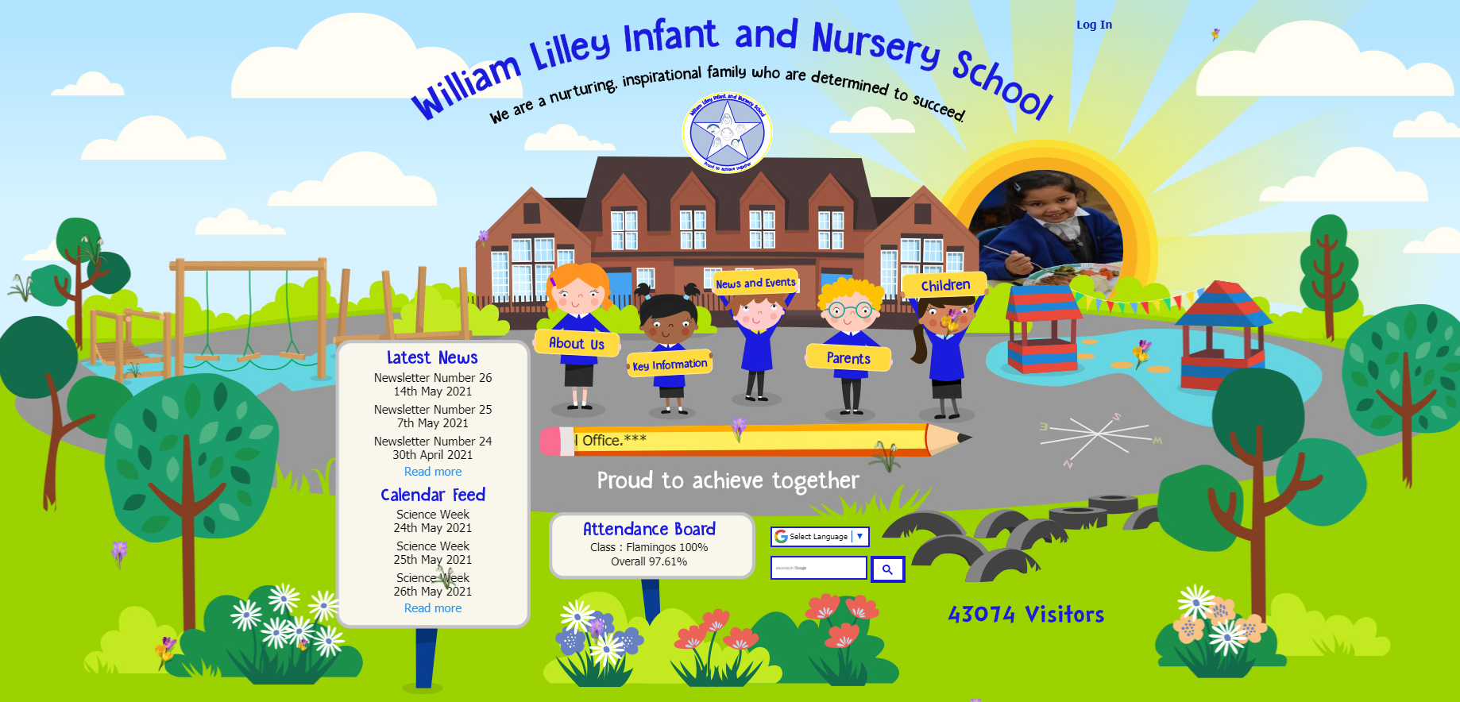


www.williamlilley.notts.sch.uk




School Policies

School Policies cover every aspect of school life. Below is a list of some of our key policies. These are regularly reviewed by our Board of Governors.
Our policies ensure that we respect and develop fundamental British values.

*Administration of Medicines*
*Antibullying Policy*
*Attendance*
*Relational Policy*
*Charging and Remissions*
*Child Protection and Safeguarding Policy*
*Complaints Procedure*
*Equality Objectives*
*GDPR Date Protection and Privacy Notice*
*Gifted and Talented*
*Homework*
*Internet Safety and Acceptable Use Policy*
*Safe Use of Children’s Photographs*
*Special Educational Needs*

Please find enclosed in this Welcome Pack
a copy of our Behaviour Policy (Child Friendly), a booklet regarding
Special Educational Needs and also some information about Attendance.

To view any of our policies, please visit our website
www.williamlilley.notts.sch.uk>key information>policies
or to obtain a hard copy, please ask at the School Office.


Uniform

Whilst uniform is not compulsory at our school, we do encourage children to wear it.
You are able to source uniform from a number of suppliers,
including supermarkets and those detailed below.

 | www.schoolwearsolutions.com  116-118 Bramcote Avenue, Chilwell, Notts, NG9 4DR  T: (01159) 258 046 E: chilwellmorleys@gmail.com
Instore and online shopping, appointments available

 | School Uniform | Embroidery & Printing Services Nottingham | Simply First  Simply First specialise in selling a wide variety of school wear, embroidery and printing services.  www.schooluniformnottingham.co.uk

Our school uniform consists of:
- Grey skirt/trousers
- White, blue or yellow polo shirt
- Royal blue cardigan/sweatshirt or jumper
Grey shorts and blue and white checked dresses are acceptable for summer.

PE Kits
- Plimsolls, dark coloured shorts, white T-shirts, socks
- Track suits and trainers ae required for outdoor PE.

Milk

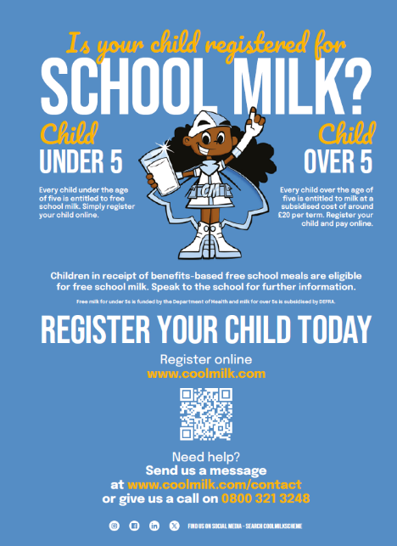
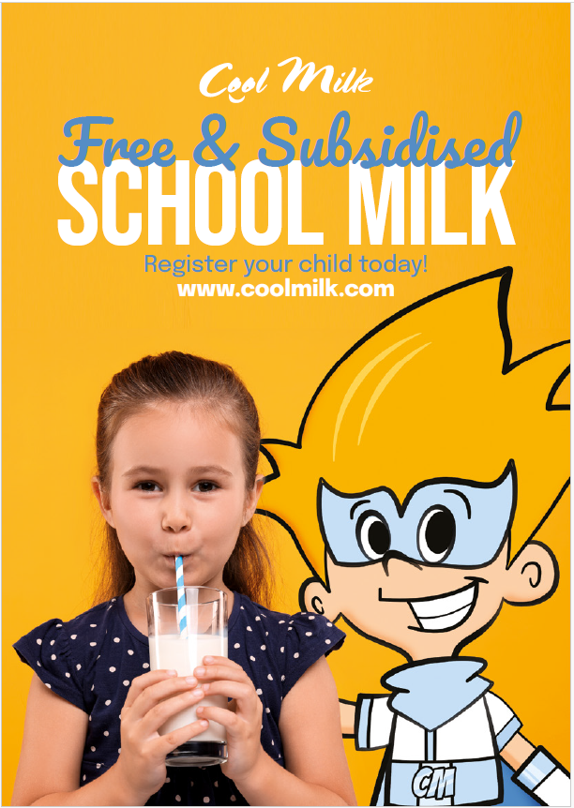

Each child that registers with Cool Milk will receive a 189ml portion of semi-skimmed milk
every day, delivered fresh and chilled to the classroom.

Their school milk will not only provide them with essential nutrients, but as it is rehydrating and energy boosting it also bridges the gap between breakfast and lunch to help children stay focused.

For more information on how milk can benefit children visit
www.coolmilk.com/why-milk-is-great.

To register your child, visit www.coolmilk.com.

Need help?
Contact the Customer Service team on 0800 321 3248 or
email registrations@coolmilk.com.

Payment System



We are a member of SchoolMoney.

This means that you have the facility to make payments for school expenses, such as trips, sports clubs, nursery dinners and lunch clubs, online with your debit or credit card.
SchoolMoney can also be used to book and pay for our before and
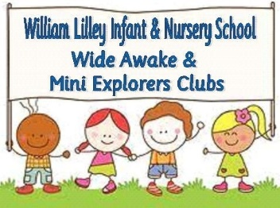
after school wrap-around sessions.

You won’t need to sign up to this system as this is done automatically through the school and as long as you have provided us with up to date contact details we will send you a password once your child is admitted to our school.

To log into SchoolMoney, visit the website www.eduspot.co.uk and click on the sign in button in the top right hand corner. In the drop down, select the SchoolMoney Parent Login option and this will send you through to a page where you need to enter your mobile number, email address, the password we have sent to you, and your child’s first name.

If for any reason you are struggling to log in, it may be because you have not provided us with the correct contact details. Please let us know immediately if either your mobile number or email address changes.

Please find enclosed a Parent User Guide in your child’s Welcome Pack to help you navigate SchoolMoney. A copy can also be found on the school website.

Further information can be obtained from the School Office.

Things to do

There is a wealth of information that we have shared within our welcome pack, don’t worry if you feel this is overwhelming as it will all make sense over time! In order to support your child’s first steps into school, we have a breakdown of ‘things to do’.
Complete the yellow ‘consent’ forms (including allergy details and preferences) | 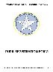
Register for ‘cool milk’ for a carton of free milk each day (or paid from 5 years old) | 
Prepare uniform, PE kit for reception only, wellies, book bag and water bottle | 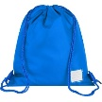
Present your child’s birth certificate at the School Office. | √
We have a wide range of different apps that support communication, information sharing and your child’s learning. Further details for these will either be shared within this booklet, your welcome pack or once your child has started in school. Please ensure you are signed up.
Application | Year Group | Purpose
  TheSchoolApp | Nursery to Year Two | School website information  Key notifications, texts and emails
  SchoolMoney | Nursery to Year Two | Before and after school club bookings,  Lunch Club (for Nursery)  School visits and trips
  Class Dojo | Nursery to Year Two | Online rewards  Direct messaging to teachers  Weekly photo sharing (Nursery and Reception)
  Oxford Owl | Reception to Year Two | Online reading (login details available in your child’s reading diary)
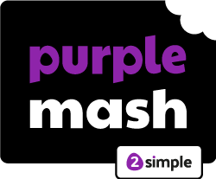  Purple MASH | Reception to Year Two | Online learning platform with a range of activities linked to different areas of the curriculum (login details available in your child’s reading diary)

