

Welcome to
William Lilley Infant and Nursery School

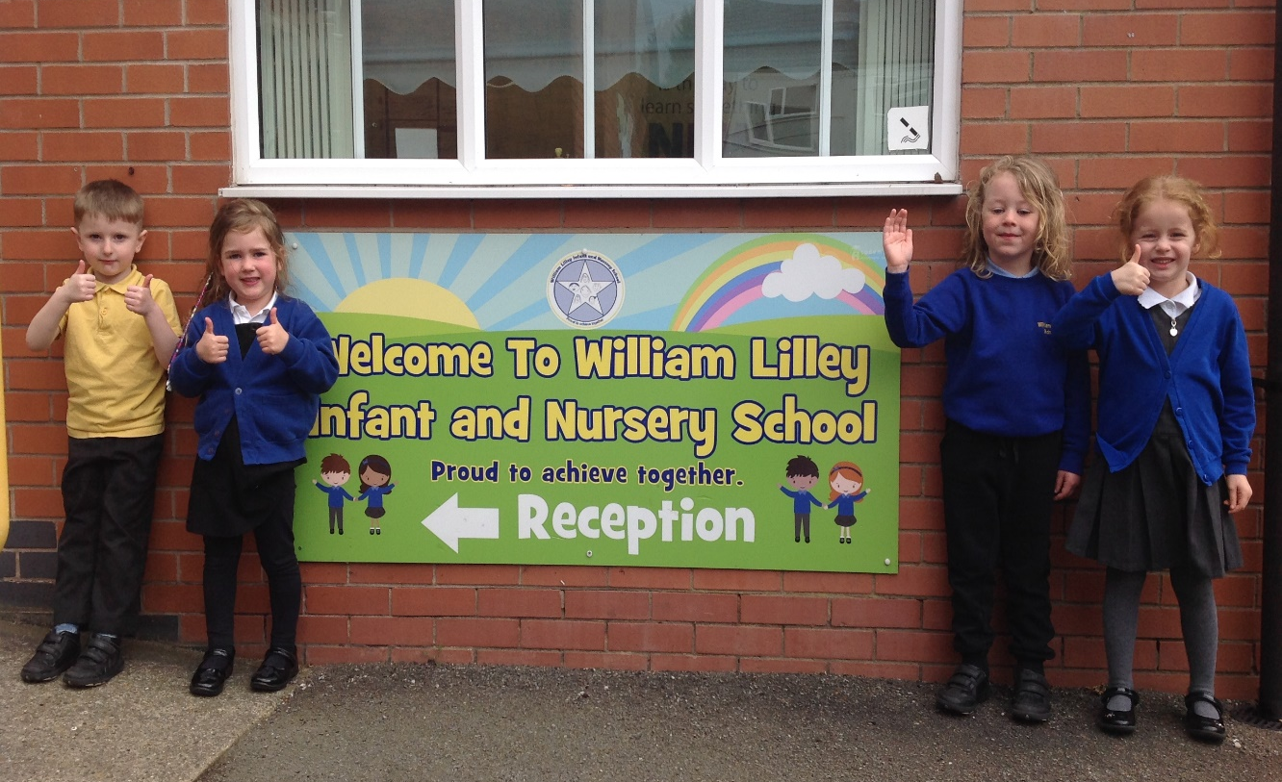

We are a nurturing, inspirational family who are determined to succeed.
This booklet provides you with all the information you need for your child starting with us at William Lilley Infant and Nursery School.
We look forward to meeting you and your child.
Please do not hesitate to contact us if you have any further questions.

2024-2025

CONTENTS

WELCOME Page 3
MEET THE EARLY YEARS TEAM Page 4
ORGANISATION Page 5

OUR CURRICULUM Page 6
OUR EARLY YEARS FOUNDATION STAGE VISION Page 7
PUNCTUALITY AND ATTENDANCE Page 8
WRAP AROUND PROVISON Page 9

CHILDREN’S SAFETY Page 10
LUNCH TIME ARRANGEMENTS Page 13
SCHOOL UNIFORM Page 14
THINGS YOUR CHILD WILL NEED Page 15
PREPARING YOUR CHILD FOR SCHOOL Page 16
CLASS DOJO Page 17
HOMEWORK Page 18
FINDING OUT ABOUT MY CHILD Page 19
WORKING TOGETHER Page 20
OUR SCHOOL GOVERNORS Page 22
PUPIL PREMIUM FUNDING Page 23

WELCOME

Thank you for choosing William Lilley Infant and Nursery school for the first steps in your child’s education. We look forward to working together to support your child to be the best they can be.
Our dedicated school community work hard to achieve our mission statement for each and every child:
We are a nurturing, inspirational family who are determined to succeed.

We are very much looking forward to your child joining our school and building a successful relationship to support the learning and development of your child. By working together, school and home can make the most of the excitement and can help to avoid any worries – not only now but also during the rest of the time that your child spends with us.
Our Welcome pack aims to answer many questions whilst also giving suggestions for ways in which you can help your child at home as a valuable part of their education. If you would like further details on our policies, practices and general daily life at William Lilley, please visit our school website at www.williamlilley.notts.sch.uk. We would welcome any comments on this booklet, the agreement or any aspect of school life.
At William Lilley Infant and Nursery School we have introduced a written agreement between home and school as a beginning of the partnership we need to adopt in your child’s education. The aim is to help your child to do their very best with our mutual support and sets out that staff. parents and children will adhere to the following goal:

TO DO EVERYTHING WITHIN OUR CAPACITY TO SUPPORT THE LEARNING AND DEVELOPMENT OF EACH CHILD.

The agreement is not, of course, a legal contract but it sets out ways in which you and we can work together. We believe that it will lead to a better understanding of the responsibilities and opportunities that lie ahead in our joint efforts to help your child. We hope that you and your child will sign both copies of the agreement and return one of them to us. If for any reason, you feel unable to sign, perhaps you would contact a member of staff so that we can discuss it and help if necessary.

There are several yellow forms enclosed in this pack for you to complete and return to school. They are important and help us to comply with Local Authority legislation. We look forward to a happy partnership between William Lilley School, you and your child.
Thank you for taking your time in reading through the details within our welcome pack. We look forward to working closely together over your child’s first years in school.

Yours sincerely
Mrs S Beardsley
HEAD TEACHER

MEET THE EARLY YEARS TEAM

(Please note that the staff members are accurate at the time of print)

NURSERY TEAM

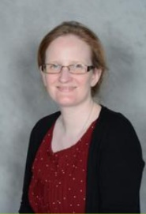




Mrs Westby
Nursery Teacher
Mrs Kitchen
Nursery TA

Mrs Turner
Nursery TA

Mrs Logue
Nursery TA




RECEPTION TEAM




Mrs Young
Brilliant Butterflies Teacher

Mrs Jeffery
Early Years Lead
Lovely Ladybirds Teacher


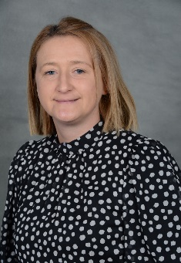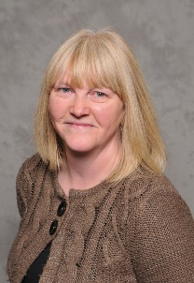
Mrs Pinner
Happy Hedgehogs in Class Support

Mrs Blakemore
Happy Hedgehogs in Class Support
Mrs Wright
Happy Hedgehogs in Class Support
ht

ORGANISATION

Busy Bees | Nursery (Age 2-4) | Foundation Stage 1
  Lovely Ladybirds | Reception (Age 4-5) | Foundation Stage 2
  Brilliant Butterflies | Reception (Age 4-5) | Foundation Stage 2
  Fabulous Flamingos | Mixed Year 1 and 2 class  (Age 5-6/6-7) | Key Stage 1
  Curious Kingfishers | Mixed Year 1 and 2 class  (Age 5-6/6-7) | Key Stage 1
  Persevering Puffins | Mixed Year 1 and 2 class  (Age 5-6/6-7) | Key Stage 1

TIMES OF THE SCHOOL DAY
Nursery
8:50am | Morning session begins
11:40am | Morning session ends
11:40am- 12:30pm | Lunch time
12:30pm | Afternoon session begins
3:20pm | Afternoon session ends

Reception
8.45am | Doors open
12:00 – 1:00pm | Lunch time
3:15pm | Home time

OUR CURRICULUM

What is the Early Years Foundation Stage Curriculum?
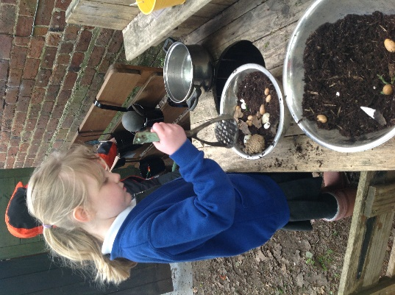
Children in the Early Years learn through play. Teachers plan a range of active, practical activities that support their development and help them to achieve their next steps in learning. The early years environments are carefully planned to create a range of learning opportunities across the curriculum. Teachers plan these opportunities based on children’s interests to motivate, engage and inspire them.
Teachers and Teaching Assistants will support learning through play by modelling, questioning, extending and challenging your child to think independently. Teachers observe the children very closely to see what they know and can do!
Teachers also plan more structured activities that support the learning taking place in the setting each week. Teachers deliver short carpet sessions that focus on an aspect of learning. This might be a maths, phonics, topic or music session.
We make good use of our outdoor learning environment too and go outside all year round and in all weathers! This shared by both Nursery and Reception children and we often play outside together.
The Early Years Foundation Stage Curriculum focuses on 7 areas of learning.
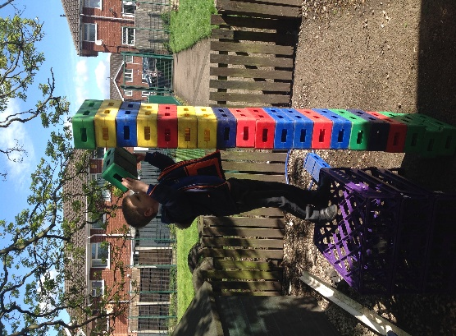
These include:
- Personal, Social and Emotional development
- Communication and Language
- Physical Development
- Literacy
- Mathematics
- Understanding the World
- Expressive Arts and Design

Each child will have their own ‘Learning Journey’ book. This is used to record any ‘WOW’ learning moments throughout the year and provide both home and school with a really valuable insight in to how they are progressing. It might show a range of photographs, staff observations and your child’s quotes.

At William Lilley, we have created a vision statement for what we aim to see in
Nursery and Reception.

OUR EARLY YEARS FOUNDATION STAGE VISION
At William Lilley Foundation Stage, play, communication and promoting
a love of learning is at the heart of all that we do.


Our happy children are nurtured and are encouraged to build strong
relationships within the school family.

Children are motivated through fun, first-hand experiences which support them to
develop their understanding of the wider world, take risks and extend their learning.

Our children are encouraged to be healthy, active learners who are
confident, independent individuals.

Our inspirational environment enables us to work together, celebrate each other
and achieve success.

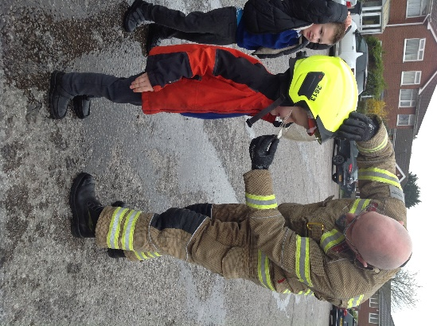

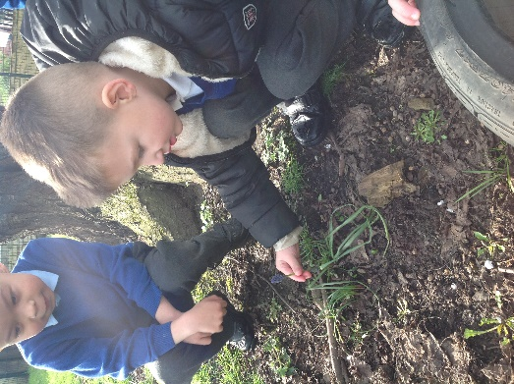
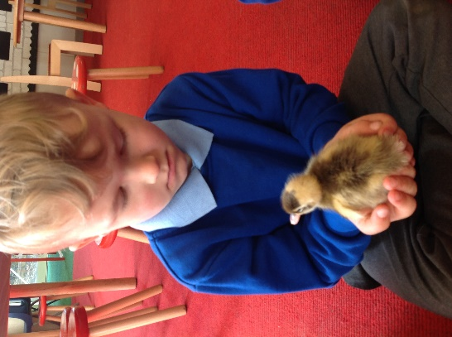

PUNCTUALITY AND ATTENDANCE

We believe that every day counts and it is very important that your child attends school regularly.
It is also important to ensure your child has a calm start to the day. Therefore, it is important to arrive punctually, and be ready to line up before the doors open. The first part of the school day helps to settle your child and they can miss important learning.

If you do happen to be late, you will need to enter the main school building and report to the Office.

Poor attendance rates and persistent lateness really is detrimental to your child’s education and can be very disruptive to their learning. They will miss many exciting learning opportunities.

SCHOOL TERM TIME HOLIDAYS
We DO NOT authorise any holidays within term time.
If you do go ahead and take the holiday, the absences will be recorded as unauthorised.
If you do decide to take a holiday during term time you will need to complete a Leave of Absence Form which you can get from the office so we are aware in advance of your intention to take leave.

ABSENCE PROCEDURE

We realise that children do get poorly from time to time and need to be at home.

It is our policy at William Lilley School to accept notification of absence by telephone call on the first morning of absence; if we do not hear from you, we will contact you via telephone asking for an explanation of absence.
In the case of sickness and stomach bugs we ask that your child stays at home for 48 hours after the last bout of sickness. This is following Public Health England recommendations.

ILLNESS IN SCHOOL
If your child is unwell when they are in school, we will contact you immediately.
We will contact parents first then follow the contact list in order that you have specified if we cannot get hold of you.
It is very important that you notify us of any change in contact details as soon as possible so that we can ensure our data is up to date in case of any emergencies.

The Local Authority and the Department for Education monitor our registers daily.

Attendance rates and lateness are recorded for all children.

For more information regarding attendance,

please see the Attendance Information booklet enclosed in this pack.

WRAP-AROUND PROVISION

We offer before and after school provision which is led and run by the school. Known staff who work with your child during the school day run our fun-filled provision within our ‘rainforest’ room.

Wide awake club is open from 7.30am until the start of the school day. This is a great opportunity for your child to come along for breakfast, along with time for meeting their friends before the school day.

Mini-explorers club is open after school until 6pm. Children have a light evening meal and join in with a range of different activities including those indoors and outdoors. The small group sizes allow for children to get to know each other and make new friends from across the school.
For more details and updated costs, please see the ‘wrap-around’ details within your pack.

We also have a range of after-school curriculum clubs which are led by teachers within the school. These run for one evening over a four week period and allow your children to engage with activities of their particular interest or talent. Please see our newsletter and updated correspondence for details of clubs each half term.

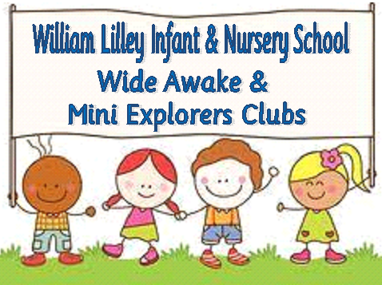


CHILDREN’S SAFETY

We would like to draw your attention to procedures which are in place to ensure both children and adults are safe whilst on the school site.
MORNINGS
To avoid unknown adults entering school, we ask parents and carers to say their goodbyes to children outside and for children to come into classrooms with their teachers and without parents. Any parent wishing to visit the school office must enter via the office entrance.

INTERNAL GATES
Please ensure you close and lock any gate once you have walked through.

OFFICE DOOR
The main building entrance door will be locked via the intercom system to control access. Any parent wishing to enter must press the buzzer and a member of staff will release the door lock. Please be patient if you have to wait. Pedestrian gates on Halls Road and Broad Oak Drive (field entrance) are locked between 9.00am and 3.05pm.

PLAYGROUND
We encourage children to use their bikes and scooters to come to school. However, in order to ensure that all children are safe on site we request the following:
- Bikes and scooters are pushed along the pathways at all times.
- Bikes and scooters are placed in the bike park from 8.35am.
- Bikes and scooters are not used on the playground after school
- Please ensure you are with your child and take full responsibility for them before and after school
Please remind your child of these rules to prevent any accidents. These rules are regularly reviewed to ensure safety on the school site. Please could we also request that School’s equipment is not used before or after school.

HOME TIME
We understand that there will be occasions where you have arranged for friends or relatives to collect your child at the end of the day. Please ensure you let us know who will be collecting your child on your behalf. We will not be able to release your child to someone other than you without your consent to do so.

CONTACT INFORMATION

Please ensure that your contact telephone numbers are always up to date with the Office. We use our an app and sometimes a text messaging service to inform parents about any changes to the school timetable, school closures and emergencies.

ROAD SAFETY

For the Health and Safety of the children we encourage children to walk to school. However, we appreciate this isn’t always possible. If you do arrive by car, please park in the car park at the bottom of Halls Road and walk up to school. For the safety of all children, cars are not permitted on the zig-zag lines. We have a bicycle/scooter stand near the main building for children to store their equipment if they use them to travel to School.

EDUCATIONAL VISITS

As part of our Curriculum we may need to take the children out to explore the local area using the consent slip completed when your child joined the School. Visits further afield often require a voluntary contribution to be made so that we can cover bus charges and admission fees. When taking children further afield a consent form from Nottinghamshire County Council will be sent home with your child.

FIRST AID

All staff have basic First Aid Training. Mrs Wright and Mrs Kitchen are our Paediatric First Aiders and Mrs Downes is our fully qualified First Aid staff who is called upon in the case of serious accidents. The teacher on duty will deal with any minor incidents e.g. cuts, grazes, bumps etc. and you will receive a ‘bump note’ to inform you of this. If your child has bumped their head you will receive a letter.


However, in cases of serious accidents, first aid will be administered and an ambulance called. If you are unobtainable, Mrs Beardsley, or a member of our Senior Management Team will act in loco parentis. It is important that emergency contact numbers are updated regularly for this reason.

ILLNESS
If your child should become ill, we will contact you to collect him/her from school. Please keep your child away from school for 48 hours if they have had diarrhoea or vomiting to prevent this from spreading. Our Office Staff can advise on the National Guidelines issued by Public Health for other illnesses that may be thought contagious.

HEAD LICE
Unfortunately, head lice are a common occurrence in school and we would ask you to check your child’s hair regularly. Should you find lice in your child’s hair, we would appreciate you taking action without delay and return your child to school after treatment. If we notice head lice in a child’s hair, we will call parents to collect them so they can be treated accordingly.

ASTHMA

Please inform school if your child suffers from Asthma as we keep an Asthma Register (see form for completion in Welcome Pack). A spare inhaler should be kept in school at all times. Inhalers need to be labelled with the child’s name and class.

MEDICINES
We can only administer prescribed medicines if needed 4 times a day. You will need to complete a consent form from the office and collect medicines at the end of the day. Please organise any medicines needed 3 times a day to be administered at home. No other medicines are allowed in school.

ALLERGIES
Please inform the School Office of any known allergies that your child has. This includes hay fever, plasters or any food allergies. We may need you to complete an additional form upon receipt of this information and would make contact in order to meet at a mutually convenient time to discuss your child’s needs.

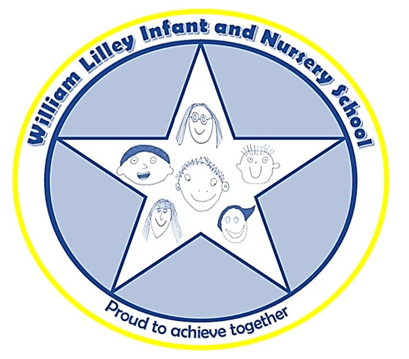

LUNCH TIME ARRANGEMENTS

LUNCHTIMES

Children in Nursery are entitled to one (15 hours attendance pattern) or two (30 hours attendance pattern) lunch club sessions per week as part of their funded entitlement. Additional Lunch Clubs incur a charge of £5.00*. A hot school dinner can be purchased at a cost of £2.95* or your child can bring in their own packed lunch. Children in Reception to Year 2 are entitled to a free hot school dinner or free school sandwiches. Children may choose to bring their own packed lunch if preferred.

SCHOOL DINNERS
A school meal menu is available on our website. Children are asked at morning register if they would like a hot meal. Parents are welcome to join us any time for a hot meal – just order on the day before 9.30am. Adult dinners cost £3.54*, which includes a main course and a desert. All our hot school dinners are prepared on site.

PACKED LUNCH
Our school promotes Healthy Eating and we are grateful for your promotion of this when you pack your child’s lunchbox. We ask that children do not bring sweets or chocolate bars (chocolate biscuits such as penguins etc. are allowed). Please ensure the lunch box is clearly labelled with their name and class. Water is provided for all children. Please put your child’s named lunch box in the boxes outside their class at the beginning of the day so that staff can check school dinner and packed lunch numbers.

ALLERGIES
Please inform staff of any allergies or special dietary requirements. The catering team are keen to encourage all children to have a school dinner and will work with you to accommodate any needs.

* prices correct at time of print.

SCHOOL UNIFORM

Our school uniform consists of
- grey skirt/trousers,
- white, blue or yellow polo shirt,
- royal blue cardigan/sweatshirt or jumper.

Grey shorts and blue and white checked dresses are acceptable for summer.

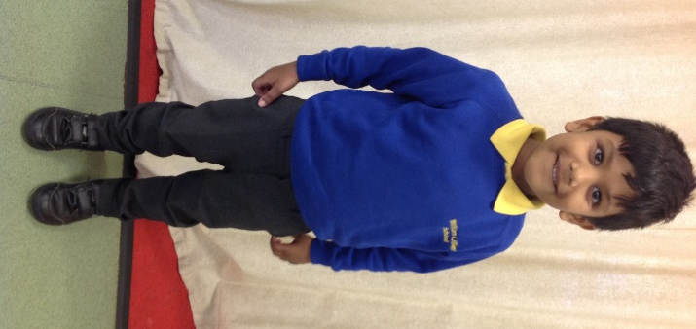
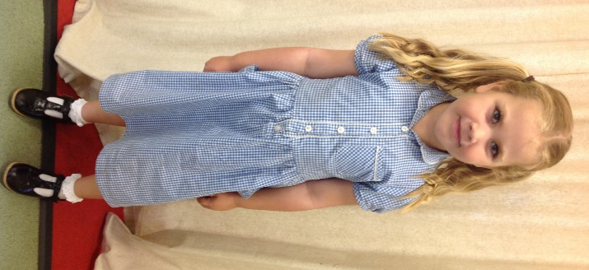

WHERE TO ORDER THE UNIFORM
Whilst uniform is not compulsory at our school, we do encourage children to wear it and embroided pieces it can be ordered from Morleys and Simply First.

JEWELLERY
We recommend you send your child without any jewellery. However, if your child has had their ears pierced, then we allow small stud earrings. If your child cannot remove earrings, plasters must be provided for PE.

THINGS YOUR CHILD WILL NEED

- Water Bottle-containing water only! Please do not fill your child’s with juice. Your child will be free to drink their water throughout the day.

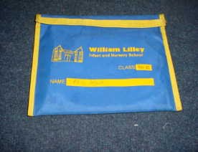

- Book Bag-all contents to be kept in the folder and brought to school every day.
You can buy these from the school office for £3.50.

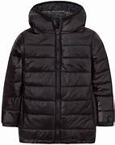
- Coat-Please bring a coat as we are outside a lot of the time!

- Wellies- these are kept on our class welly stands as we use them all year round. It can get very muddy in our outdoor area!
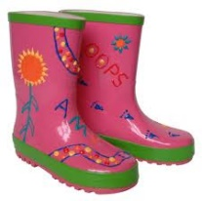

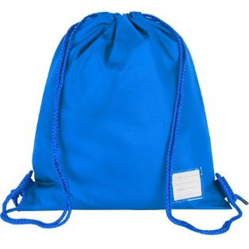
PE KITS (for Reception children)
Please send in a named bag; they will stay at school and be sent home each half term to be washed.
- plimsolls
- dark coloured shorts
- white T-shirts
- socks
- track suits and trainers are required for outdoor PE.

Please make sure that every item of uniform is clearly labelled with your child’s name!

PREPARING YOUR CHILD FOR SCHOOL

Your child doesn’t need to be able to read, write or do sums before they start school.
Children start school with a wide range of abilities and we will help your child progress at their own level.

What’s most important is that you and your child have fun together in those pre school
months and years – sharing stories, singing songs, playing games and talking about
anything and everything.

Here are a few tips to get your child ready…….

- Chat with your child about starting school. What do they think it will be like? What are they most looking forward to? Is there anything they’re unsure or worried about? You could look at our school website together and talk about the pictures. If your child seems anxious about school, try focusing on the things they’ll like best, maybe the sandpit, riding the bikes or making new friends.

- Take trips past school and point to the building, playground etc. Practise doing the school run too!

- Let your child practise putting on their school clothes, taking them off in preparation for PE lessons, especially if there are fiddly fastenings such as shirt buttons and zips. Clothes with elastic bands and shoes with Velcro are easier to handle for young children. Teach your child tricks such as putting labels at the back, holding cuffs to stop sleeves riding up, and wrinkling tights to put toes in first.

- Support your child to be confident about getting to the toilet in time and wiping
properly, using toilet paper rather than moist wipes. (We do have spare pants and clothes in case of an accident but some children like to keep their own in a bag on their peg).

- Children having school dinners need to be able to use a knife and fork. If your child is having packed lunches, practise opening and closing the lunch box and opening any wrappers too!

- Get your child into the habit of hanging their coat up, putting their toys away, clearing the table, and so on, to prepare them for doing these things at school.

Please don’t worry if your child has difficulties with any of the above.
We will do all that we can to support them at school and they usually pick things up quickly.

JOIN US ON CLASS DOJO!

Class Dojo is a school communication platform that teachers and families can use to link learning at school and at home by sharing photos, videos and messages.


We will send you an invite to join our class Dojo within the first week or so of your child starting school. Please download the app and follow the link.

Children collect PROUD points and these can be seen by parents as they earn them throughout the day.
Our top 5 earners each week will receive a sticker awarded in assembly.
In EYFS, we will use the Class story feature to share photos of what we get up to. This is invaluable for starting conversations at home and encourages communication. It also gives you ideas of things that you could do at home.

HOMEWORK

Children have weekly ‘wow’ sheets which suggest activities to complete at home.
We also use the ‘Class Dojo’ online app for recording rewards and sharing activities that have been completed at school.

We request that you support your child with regular reading at home. Your child will bring home books to share at home. Please take the time to share these with your child, supporting them to develop a love of reading. You may want to supplement these with our online books in reception. We will share a link to Oxford Owl in your child’s reading diary.
In addition to this, teachers set termly homework challenges that link to class topics. These are celebrated at the end of each term and children are awarded with a certificate and parents are invited to the celebration.

Your reception child will also have access to our online learning platform ‘Purple MASH’. On this platform your child can explore many different areas of learning. Further details will be shared through your child’s reading diary.

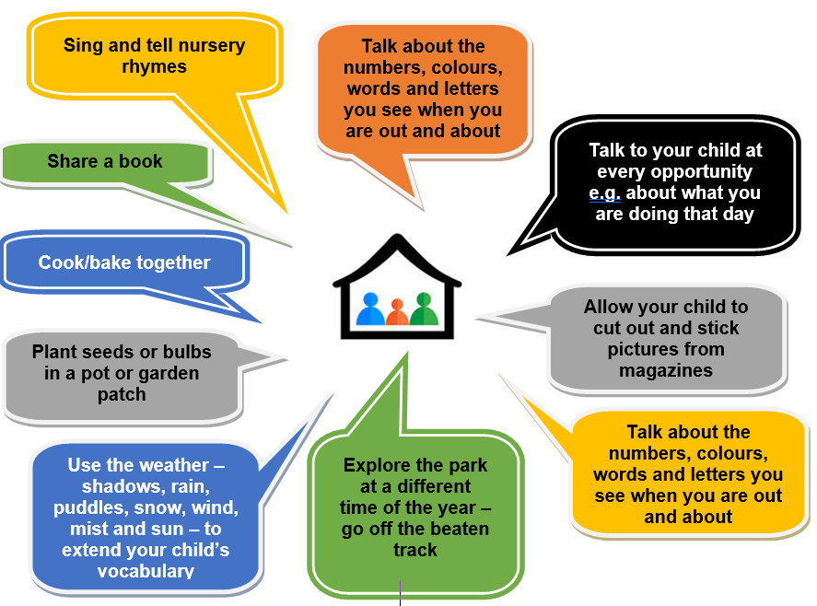
Here are some other ways that you can support your child at home;

FINDING OUT ABOUT MY CHILD

It is important that you and the professionals caring for your child work together. You need to feel comfortable about exchanging information and discussing things that will benefit your child.

You will have parents evenings in the Autumn and Spring term when you can talk about your child’s development.

You will have a written report at the end of Nursery and again at the end of Reception when you will have information about how your child is doing.

When your child starts school, teachers will assess your child’s strengths, this will help them to support their development throughout the year.

At the beginning of Reception – within the first six weeks of school – we complete the National ‘Baseline’ assessment. This is an practical assessment which is completed with a member of staff. Records from the assessment are used to support our own in-house assessments and observations.

At the end of the EYFS – in the summer term of the Reception year in school – teachers complete an assessment and make carful judgments against a number of Early Learning Goals. These goals are a measure to assess whether your child is meeting Age Related expectations. Your child’s teacher will inform you of this in your child’s end of Reception report. This assessment is carried out by the reception teacher and is based on what they, and other staff caring for your child, have observed over a period of time.

Your knowledge about your child’s learning and development is also very important to teachers when making their assessments, so please do let your child’s class teacher know about what your child does with you: such as how confident your child is in writing their name, reading and talking about a favourite book, speaking to people your child is not so familiar with or their understanding of numbers.

WORKING TOGETHER

HELPERS IN SCHOOL


Parents are very welcome to help in school. We would suggest that you let your children settle into school first then approach the class teacher or Mrs Beardsley if you would like to help in another class. We even have Grandparents offering some support! Any help that is offered is much appreciated.

VISITORS
Any visitors to the school need to have an induction, sign in at school office and wear a “visitors” badge.

‘OPEN DOOR POLICY’

At William Lilley we have an ‘Open Door Policy’. This means that you are always welcome to come into school if you have any queries or worries, however small they may seem. The time schedule for the morning is very limited and we are busy with the children so we ask that you try to see us after school. If you wish to talk to Mrs Beardsley please make an appointment at the School Office or contact her by email at head@williamlilley.notts.sch.uk.

BEHAVIOUR

We are very proud of our exceptional behaviour at William Lilley, due to parents and school working together. At William Lilley Infant and Nursery School we want everyone to feel happy, safe and secure. We have a Relationalr Policy, which emphasises and rewards good behaviour. This supports children to understand their own feelings and supports their self-regulation. We rely on your support in this. We have a process to handle unacceptable behaviour which you become involved in should the need arise. Please see our website for further information.

REWARDS
Throughout the week, children earn ‘PROUD’ points for adhering to the ‘PROUD’ rules.
- Polite
- Respectful
- Organised
- Understanding
- Determined

Head Teacher Awards are assigned by Mrs Beardsley for very good work and behaviour. Weekly. We have a regular ‘PROUD’ Assembly where a child from each class is chosen and praised by the class and whole school. We also have WOW certificates, CROW Award (Class register of the Week Award), Attendance Awards, CAT Award (Clean and Tidy Award) and notes home. Please see the Child Behaviour Policy for more details which can be found on our website and a copy is included in your child’s Welcome Pack.

COMMUNICATION

Each week we share a newsletter which includes information, successes, upcoming events and activities for each year group. We ask for you to download SchoolApp and complete the consent forms to allow us to share notifications, text messages and emails. Our newsletter will be shared through a notification each week. If you require this information in a different format, please get in contact with the school office.

We engage with a variety of first-hand activities and events. Sometimes this includes taking children on school visits and trips. We request that you complete the relevant consent forms to allow your child to participate in these activities.

On occasion, we ask for a voluntary donation to cover costs associated with such enrichment activities. All bookings and associated costs are managed within the SchoolMoney App. Please see further details within your welcome pack.

OUR SCHOOL GOVERNORS

We have a very committed team of Governors who help Mrs Beardsley lead the school. Bev Cameron is our Chair of Governors. Governors are elected from a number of areas; staff, parents, the community and the Local Authority. Governor names can be found below and pictures can be found on the Who’s Who Noticeboard in the Main Reception.

Mrs Bev Cameron Chair, LA governor
Mrs Sally Beardsley Headteacher
Miss Trudy McMahon Staff : Co-opted
Mrs Jacqueline Jenkins Co-opted
Mr John Slater Vice-Chair Co-opted

Mr A Billingham Co-opted

Ms A Tainton Parent
Miss J Bult Parent

Mr A Eames Parent
Vacancy Parent
Mr J Oleshko Associate (Co-opted from Sept 2024)

What the Government regulations say about Governors
The Governing Body must act with integrity, objectivity and honesty and in the best interests of the school, to carry out their functions with the aim of taking a largely strategic role in the running of the school. This includes setting its aims and objectives, setting policies and targets for achieving the objectives, reviewing progress and reviewing the strategic framework in the light of progress. The Governing Body should act as a critical friend to the Head Teacher by providing advice and support. (Regulation 4)

Every term the Governing Body meets with Mrs Beardsley to talk about what is happening in school, celebrate our successes and discuss what we need to do to improve things. We all work together (staff, parents, members of the community, members of the local authority) to make decisions about the school and help Mrs Beardsley with the running of the school.

Governors also help the teachers by linking with a teacher and helping them with their curriculum area e.g. Maths, Science.
Governors also like meeting the other staff and children, so we have Governor Days where they come into school for a day and see what a normal day in school is like. Governors work in the classroom with the children, talk to the staff and parents, have lunch with everyone and generally have a great time.

If you are interested in supporting our Governing Body, Mrs Beardsley would love to hear from you!

PUPIL PREMIUM FUNDING

Pupil Premium is an additional grant given to schools to help encourage the attainment of children.

We encourage all parents who receive one of the benefits below to apply, in confidence, for the grant.:
- Child Tax Credit, provided they are not entitled to Working Tax Credit and have an annual income (as assessed by His Majesty’s Revenue & Customs (HMRC)) that does not exceed £16,190
- Income Support
- Income-based Jobseeker's Allowance (JSA)
- Income-related Employment and Support Allowance (ESA)
- Income-based and Contributions-based JSA and ESA on an equal basis
- Support under Part VI of the Immigration and Asylum Act 1999
- The Guarantee element of State Pension Credit
- Working Tax Credit run-on – paid for four weeks after the person stops qualifying for Working Tax Credit
- Universal Credit – during the initial roll-out of the benefit

How to apply
You can apply for Free School Meals by contacting Nottinghamshire County Council by phone on 0300 500 80 80 or preferably by applying online at www.nottinghamshire.gov.uk – click on the ‘Browse Website’ tab – go to Education – School Meals – Free Meals & Milk. If you scroll to the bottom of the page there are links to ‘register and apply online’.
Once you have applied we will be notified if your application is successful.
This extra funding helps the school to make a real difference to those children.
We use the Pupil Premium money in a number of ways to help raise attainment and provide enriching experiences.
For every child who qualifies we receive £1300 to support them in school

What do we spend Pupil Premium money on?
· Extra Teaching Assistant support
· Intervention and Booster groups
· Individualised support for Pupil Premium children depending on their needs
· Challenging high achievers through workshops, projects and enrichment activities
· Extra-curricular activities, trips etc

Please do not hesitate to speak to an adult should you have any questions.
We know that there is a lot of new information…
And we will do all that we can to make you and your child part of the William Lilley Family!

